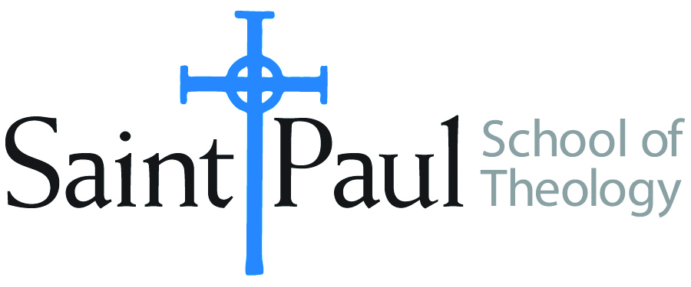
COURSE TEXTBOOK LIST INFORMATION

FACULTY INSTRUCTIONS |  |  | STUDENT INSTRUCTIONS  (Both Campuses)
For each semester taught, faculty should complete and submit a new form for every course and return to Ethel Tomlinson, Registrar Clerk/Administrative Support. Forms are due by the first day of registration for a given term. Desk copies for Teaching Assistants must be requested on this form. It is up to the publishers’ discretion whether or not to provide desk copies for teaching assistants. |  |  | Students may acquire textbooks by ordering online or directly from the publisher, which in some cases, the prices are more economical. Regardless of shopping/ordering method, students may check Cokesbury online for discount on text, or follow recommendations by your professor.
COURSE INSTRUCTOR(S) | Dr. Kimberly D. Russaw
COURSE NUMBER & SECTION | HBS 422
COURSE NAME | Women in Genesis
COURSE SEMESTER &YEAR | Spring 2018
DATE OF SUBMISSION | November 10, 2017

REQUIRED TEXTBOOKS LIST
BOOK TITLE and EDITION  (include subtitle if applicable) |  | AUTHOR(S) | No. of  PAGES to be read | PUBLISHER and DATE | 13-Digit ISBN  (without dashes) | LIST PRICE  (estimate) | DESK COPY
1 | Womanist Midrash: A Reintroduction to the Women of the Torah and the Throne | Wil Gafney |  | Westminster John Knox, 2017 | - 978-0664239039 | $25.00
2 | Women in Genesis | Sharon Jeansonne |  | Fortress, 1990 | 978-0800624194 | $20.00
3 | An NRSV Bible
4
5
6
7
 | TOTAL Number of Pages to Be Read

RECOMMENDED TEXTBOOKS LIST
BOOK TITLE and EDITION  (include subtitle if applicable) |  | AUTHOR(S) | No. of  PAGES to be read | PUBLISHER and DATE | 13-Digit ISBN  (without dashes) | LIST PRICE  (estimate) | DESK COPY
1 | Rediscovering Eve: Ancient Israelite Women in Context | Carol Meyers |  | Oxford University Press, 2012 | 978-0199734627 | $27.00
2
3
4

