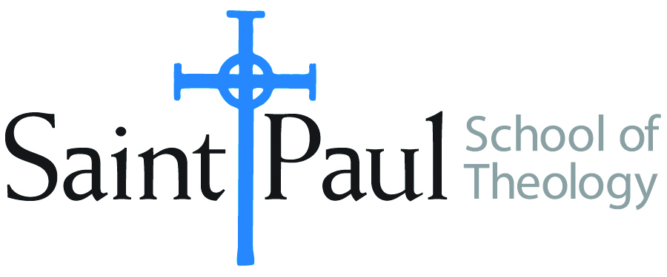
COURSE TEXTBOOK LIST INFORMATION

FACULTY INSTRUCTIONS |  |  | STUDENT INSTRUCTIONS  (Both Campuses)
For each semester taught, faculty should complete and submit a new form for every course and return to Melissa Whalen in the Academic Life office. Forms are due by the first day of registration for a given term. Desk copies for Teaching Assistants must be requested on this form. It is up to the publishers’ discretion whether or not to provide desk copies for teaching assistants. |  |  | Students may acquire textbooks by ordering online via Amazon Associate on our website and having books shipped to them. Regardless of shopping/ordering method, students may check Cokesbury online for discount on text and certain text may be sent free delivery.
COURSE INSTRUCTOR(S) | James Brandt & Amy Oden
COURSE NUMBER & SECTION | DMin 550
COURSE NAME | Praxis Thesis Seminar
COURSE SEMESTER &YEAR | Spring 2018
DATE OF SUBMISSION | Oct. 15, 2017

REQUIRED TEXTBOOKS LIST
BOOK TITLE and EDITION  (include subtitle if applicable) |  | AUTHOR(S) | No. of  PAGES to be read | PUBLISHER and DATE | 13-Digit ISBN  (without dashes) | LIST PRICE  (estimate) | DESK COPY
1 | Research Strategies 6th ed. | Badke, William | 342 | iUniverse LLC, 2017 | 9781532018039 | $21 | yes
2 | Ethnography as Pastor Practice: An Introduction | Moschella, Mark Clark | 250 | Pilgrim Press 2008 | 9780829817744 | $25 | yes
3 | How to Think Theologically, 3rd ed. | Stone, Howard & Duke, James | 152 | Fortress Press, 2013 | 9780800699321 | $13 | yes
4 | A Manual for Writers of Research Papers, Theses, and Dissertations | Turabian, Kate L. |  | University of Chicago Press, 2013 | 9780226816388 | $12
5
6
7
 | TOTAL Number of Pages to Be Read |  | 744

RECOMMENDED TEXTBOOKS LIST
BOOK TITLE and EDITION  (include subtitle if applicable) |  | AUTHOR(S) | No. of  PAGES to be read | PUBLISHER and DATE | 13-Digit ISBN  (without dashes) | LIST PRICE  (estimate) | DESK COPY
1
2
3
4

Special Instructions to Cokesbury:

