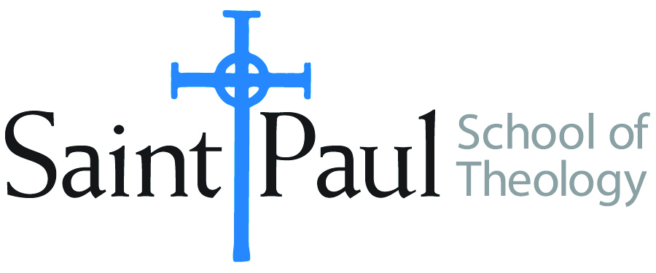
COURSE TEXTBOOK LIST INFORMATION

FACULTY INSTRUCTIONS |  |  | STUDENT INSTRUCTIONS  (Both Campuses)
For each semester taught, faculty should complete and submit a new form for every course and return to Melissa Whalen in the Academic Life office. Forms are due by the first day of registration for a given term. Desk copies for Teaching Assistants must be requested on this form. It is up to the publishers’ discretion whether or not to provide desk copies for teaching assistants. |  |  | Students may acquire textbooks by ordering online via Amazon Associate on our website and having books shipped to them. Regardless of shopping/ordering method, students may check Cokesbury online for discount on text and certain text may be sent free delivery.
COURSE INSTRUCTOR(S) | Anne Walker
COURSE NUMBER & SECTION | CRE 382 AOE
COURSE NAME | Youth Ministry
COURSE SEMESTER &YEAR | Spring 2018
DATE OF SUBMISSION | 10/10/2017

REQUIRED TEXTBOOKS LIST
BOOK TITLE and EDITION  (include subtitle if applicable) |  | AUTHOR(S) | No. of  PAGES to be read | PUBLISHER and DATE | 13-Digit ISBN  (without dashes) | LIST PRICE  (estimate) | DESK COPY
1 | OMG: A Youth Ministry Handbook | Dean | 163 | Abingdon, 2010 | 978-1426700088 | 15.07
2 | Living and Learning with New Media | Ito | 120 | MIT Press, 2009 | 978-0262513654 | 20.00
3 | Safe Sanctuaries | Melton | 144 | Discipleship Resources, 144  2008 | 978-0881775433 | 24.24
4 | Nurturing Different Dreams | Turpin | 150 | Pickwick, 2014 | 978-1625640093 | 19.35
5 | Practicing Discernment with Youth | White | 209 | Pilgrim, 2005 | 978-0829816310 | 8.98
6 | Soul Searching |  |  | 2006 Documentary (digital) |  | 9.99
7
 | TOTAL Number of Pages to Be Read

RECOMMENDED TEXTBOOKS LIST
BOOK TITLE and EDITION  (include subtitle if applicable) |  | AUTHOR(S) | No. of  PAGES to be read | PUBLISHER and DATE | 13-Digit ISBN  (without dashes) | LIST PRICE  (estimate) | DESK COPY
1
2
3
4

Special Instructions to Cokesbury:

