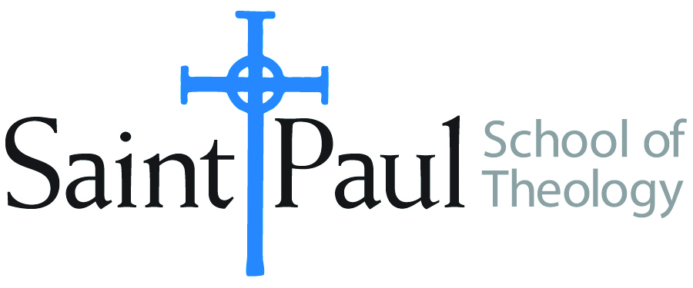
COURSE TEXTBOOK LIST INFORMATION

FACULTY INSTRUCTIONS |  |  | STUDENT INSTRUCTIONS  (Both Campuses)
For each semester taught, faculty should complete and submit a new form for every course and return to Melissa Whalen in the Academic Life office. Forms are due by the first day of registration for a given term. Desk copies for Teaching Assistants must be requested on this form. It is up to the publishers’ discretion whether or not to provide desk copies for teaching assistants. |  |  | Students may acquire textbooks by ordering online via Amazon Associate on our website and having books shipped to them. Regardless of shopping/ordering method, students may check Cokesbury online for discount on text and certain text may be sent free delivery.
COURSE INSTRUCTOR(S) | Casey Thornburgh Sigmon
COURSE NUMBER & SECTION | CHS 515
COURSE NAME | Prophetic Ministry (DMIN INTENSIVE HYBRID)
COURSE SEMESTER &YEAR | Spring 2018
DATE OF SUBMISSION | 10/13/2017

REQUIRED TEXTBOOKS LIST
BOOK TITLE and EDITION  (include subtitle if applicable) |  | AUTHOR(S) | No. of  PAGES to be read | PUBLISHER and DATE | 13-Digit ISBN  (without dashes) | LIST PRICE  (estimate) | DESK COPY
1 | GOOD FOOD: GROUNDED PRACTICAL THEOLOGY | JENNIFER R. AYRES | 164 | BAYLOR, 2013 | 9781602589841 | 26.94
2 | THE PROPHETIC IMAGINATION 2ND EDITION | WALTER BRUEGGEMANN | 126 | FORTRESS, 2001 | 9780800632878 | 17.07
3 | NATIVE AMERICANS, THE MAINLINE CHURCH, AND THE QUEST FOR INTERRACIAL JUSTICE | DAVID PHILLIPS HANSEN | 139 | CHALICE, 2016 | 9780827225282 | 21.68
4 | PROPHETIC ATIVISM: PROGRESSIVE RELIGIOUS JUSTICE MOVEMENTS IN CONTEMPORARY AMERICA | HELENE SLESSAREV-JAMIR | 190 | NYU PRESS, 2011 | 9780814741238 | 30.00
5 | TROUBLE I’VE SEEN: CHANGING THE WAY THE CHURCH VIEWS RACISM | DREW G.I. HART | 185 | HERALD PRESS, 2016 | 9781513800004 | 14.46 | x
6 | TRANSFORMING THE STONE: PREACHING THROUGH RESISTANCE TO CHANGE | BARBARA K. LUNDBLAD | 150 | ABINGDON, 2001 | 9780687096138 | 14.52
7 | CHRISTIANS AT THE BORDER: IMMIGRATION, THE CHURCH, AND THE BIBLE 2ND EDITION | M. DANIEL CARROLL R. | 140 | BRAZOS PRESS, 2013 | 9781587433511 | 12.87 | x
 | TOTAL Number of Pages to Be Read |  | 1,029

RECOMMENDED TEXTBOOKS LIST
BOOK TITLE and EDITION  (include subtitle if applicable) |  | AUTHOR(S) | No. of  PAGES to be read | PUBLISHER and DATE | 13-Digit ISBN  (without dashes) | LIST PRICE  (estimate) | DESK COPY
1 | It comes from the People: Community Development and Local Theology | Mary Ann Hinsdale, Helen M. Lewis, S. Maxine Waller | 150 | Temple University, 1995 | 9781566392129 | 24.76 | x
2 | God Has A Dream: A Vision of Hope for Our Time | Desmond Tutu | 40 | Image Book, 2005 | 9780385483711 | 11.44
3 | Doing Christian Ethics from the Margins: 2nd Edition | Miguel A. De La Torre | 384 | Orbis Books, 2014 | 9781626980754 | 28.82 | x
4

Special Instructions:

