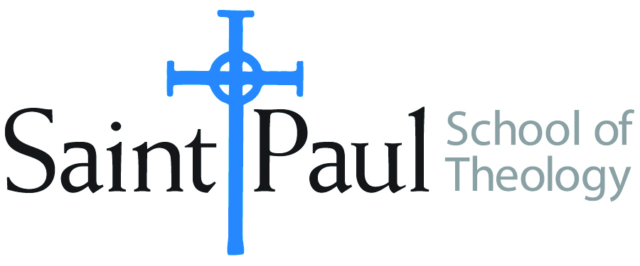
COURSE TEXTBOOK LIST INFORMATION

FACULTY INSTRUCTIONS |  |  | STUDENT INSTRUCTIONS  (Both Campuses)
For each semester taught, faculty should complete and submit a new form for every course and return to Melissa Whalen in the Academic Life office. Forms are due by the first day of registration for a given term. Desk copies for Teaching Assistants must be requested on this form. It is up to the publishers’ discretion whether or not to provide desk copies for teaching assistants. |  |  | Students may acquire textbooks by ordering online via Amazon Associate on our website and having books shipped to them. Regardless of shopping/ordering method, students may check Cokesbury online for discount on text and certain text may be sent free delivery.
COURSE INSTRUCTOR(S) | Elaine Robinson
COURSE NUMBER & SECTION | CHL422 ADV and AOV
COURSE NAME | Leading the Multi-Ethnic Church
COURSE SEMESTER &YEAR | Spring 2018
DATE OF SUBMISSION | October 10, 2017

REQUIRED TEXTBOOKS LIST
BOOK TITLE and EDITION  (include subtitle if applicable) |  | AUTHOR(S) | No. of  PAGES to be read | PUBLISHER and DATE | 13-Digit ISBN  (without dashes) | LIST PRICE  (estimate) | DESK COPY
1 | Building a Healthy Multi-  Ethnic Church | DeYmaz, Mark | 184 | John Wiley & Sons,2007 | 9780787995515 | $20
2 | White Privilege: Essential  Readings on the Other Side of  Racism, 5th Edition | Rothenberg, Paula S. | 200 | Worth Publishers, 2015 | 9781429242202 | $45 (ebook $28) | X
3 | One Body, One Spirit:  Principles of Successful  Multiracial Churches | Yancey, George | 177 | IVP Books, 2003 | 9780830832262 | $18
4
5
6
7
 | TOTAL Number of Pages to Be Read

RECOMMENDED TEXTBOOKS LIST
BOOK TITLE and EDITION  (include subtitle if applicable) |  | AUTHOR(S) | No. of  PAGES to be read | PUBLISHER and DATE | 13-Digit ISBN  (without dashes) | LIST PRICE  (estimate) | DESK COPY
1 | Race and Theology | Robinson, Elaine |  | Abingdon, 2012 | 9780687494255 | $11
2
3
4

Special Instructions to Cokesbury:

