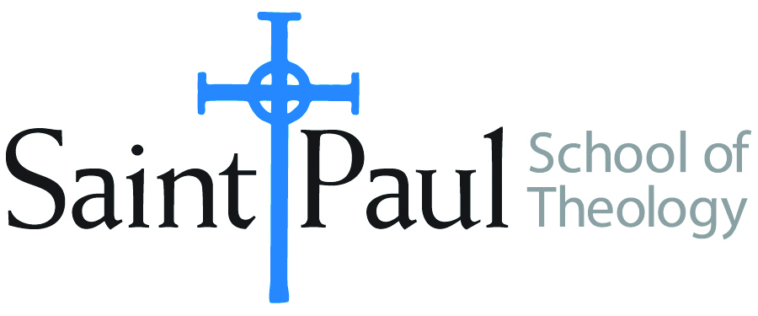
KCOURSE TEXTBOOK LIST INFORMATION

FACULTY INSTRUCTIONS |  |  | STUDENT INSTRUCTIONS  (Both Campuses)
For each semester taught, faculty should complete and submit a new form for every course and return to Ethel Tomlinson, Registrar Clerk/Administrative Support. Forms are due by the first day of registration for a given term. Desk copies for Teaching Assistants must be requested on this form. It is up to the publishers’ discretion whether or not to provide desk copies for teaching assistants. |  |  | Students may acquire textbooks by ordering online or directly from the publisher, which in some cases, the prices are more economical. Regardless of shopping/ordering method, students may check Cokesbury online for discount on text, or follow recommendations by your professor.
COURSE INSTRUCTOR(S) | Kristen Kvam
COURSE NUMBER & SECTION | ASR 420
COURSE NAME | Summative Seminar
COURSE SEMESTER &YEAR | Spring 2018
DATE OF SUBMISSION | October 2017

REQUIRED TEXTBOOKS LIST
BOOK TITLE and EDITION  (include subtitle if applicable) |  | AUTHOR(S) | No. of  PAGES to be read | PUBLISHER and DATE | 13-Digit ISBN  (without dashes) | LIST PRICE  (estimate) | DESK COPY
1 | Jesus the Savior: The Meaning of Jesus Christ for Christian Faith | Placher, William C. | 225 | Westminster John Knox, 2001 | 9780664223915 | $10.93 | yes
2 | Christ and Culture | Niebuhr, H. Richard | 250 | Harper Collins, 1956 | 9780060904319 | $3.64 | yes
 | TOTAL Number of Pages to Be Read |  | 475 pages

RECOMMENDED TEXTBOOKS LIST
BOOK TITLE and EDITION  (include subtitle if applicable) |  | AUTHOR(S) | No. of  PAGES to be read | PUBLISHER and DATE | 13-Digit ISBN  (without dashes) | LIST PRICE  (estimate) | DESK COPY
1 | Dictionary of Feminist Theologies | Russell, Letty, and J. Shannon Clarkson, ed. |  | Westminster John Knox, 2004 | 9780664229238 | $26.81
2 | Handbook of Christian Theology | Musser, Donald and Joseph Price, ed. |  | Abingdon, 2003 | 9780687091126 | 12.95
3 | Christian Confessions: A Historical Introduction | Campbell, Ted |  | Westminster John Knox, 1996 | 9780664256500 | 1.99
4 | Ecumenical Movement: An Anthology of Key Texts and Voices | Kinnamon, Michael and Brian Cope, ed. |  | Wm. B. Eerdmans, 1997 | 9782825411872 | 1.99

