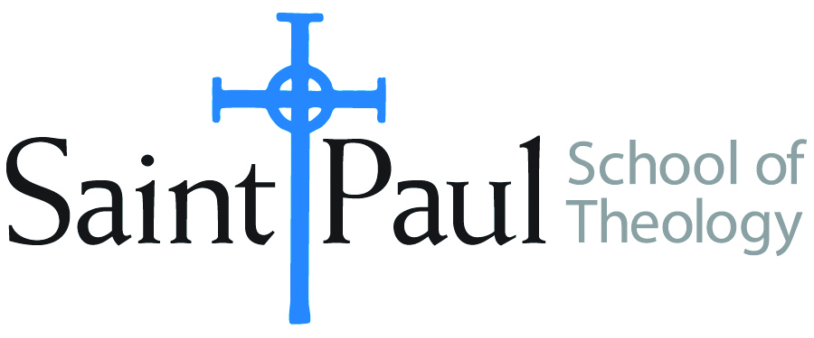
COURSE TEXTBOOK LIST INFORMATION

FACULTY INSTRUCTIONS |  |  | STUDENT INSTRUCTIONS  (Both Campuses)
For each semester taught, faculty should complete and submit a new form for every course and return to Melissa Whalen in the Academic Life office. Forms are due by the first day of registration for a given term. Desk copies for Teaching Assistants must be requested on this form. It is up to the publishers’ discretion whether or not to provide desk copies for teaching assistants. |  |  | Students may acquire textbooks by ordering online via Amazon Associate on our website and having books shipped to them. Regardless of shopping/ordering method, students may check Cokesbury online for discount on text and certain text may be sent free delivery.
COURSE INSTRUCTOR(S) | Kyle Butler
COURSE NUMBER & SECTION | THL 521
COURSE NAME | Theology and the Church’s Ministry
COURSE SEMESTER &YEAR | Fall 2017
DATE OF SUBMISSION

REQUIRED TEXTBOOKS LIST
BOOK TITLE and EDITION  (include subtitle if applicable) |  | AUTHOR(S) | No. of  PAGES to be read | PUBLISHER and DATE | 13-Digit ISBN  (without dashes) | LIST PRICE  (estimate) | DESK COPY
1 | The Politics of Discipleship | Graham Ward | 280 | Baker Academic, 2009 | 978-0801031588 | $28 | No
2 | Christology: A Global Introduction (2nd Edition) | Veli-Matti Kärkkäinen | 250 | Baker Academic, 2016 | 9780801030888 | $16 | No
3
4
5
6
7
 | TOTAL Number of Pages to Be Read |  | 530

RECOMMENDED TEXTBOOKS LIST
BOOK TITLE and EDITION  (include subtitle if applicable) |  | AUTHOR(S) | No. of  PAGES to be read | PUBLISHER and DATE | 13-Digit ISBN  (without dashes) | LIST PRICE  (estimate) | DESK COPY
1
2
3
4

Special Instructions to Cokesbury:

