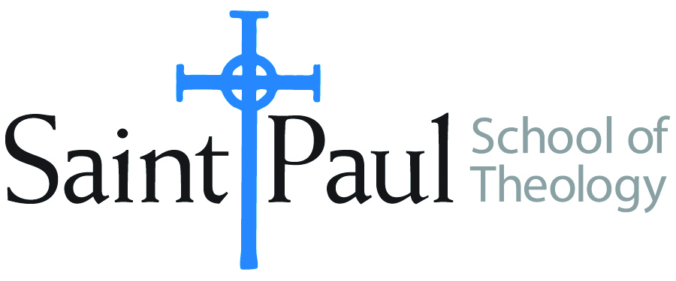
COURSE TEXTBOOK LIST INFORMATION

FACULTY INSTRUCTIONS |  |  | STUDENT INSTRUCTIONS  (Both Campuses)
For each semester taught, faculty should complete and submit a new form for every course and return to Melissa Whalen in the Academic Life office. Forms are due by the first day of registration for a given term. Desk copies for Teaching Assistants must be requested on this form. It is up to the publishers’ discretion whether or not to provide desk copies for teaching assistants. |  |  | Students may acquire textbooks by ordering online via Amazon Associate on our website and having books shipped to them. Regardless of shopping/ordering method, students may check Cokesbury online for discount on text and certain text may be sent free delivery.
COURSE INSTRUCTOR(S) | Amy Oden
COURSE NUMBER & SECTION | SFR 501
COURSE NAME | Spiritual Formation for Ministry 1
COURSE SEMESTER &YEAR | Fall 2017
DATE OF SUBMISSION | March 5, 2017

REQUIRED TEXTBOOKS LIST
BOOK TITLE and EDITION  (include subtitle if applicable) |  | AUTHOR(S) | No. of  PAGES to be read | PUBLISHER and DATE | 13-Digit ISBN  (without dashes) | LIST PRICE  (estimate) | DESK COPY
1 | Psalms of the Jewish Liturgy: A Guide to Their Beauty, Power, and Meaning | Miryam Glazer | 250 | Aviv Press, 2009 | 9780916219413 | 11.00 | no
2 | Thirsty for God, A Brief History of Christian Spirituality. | Holt, Bradley P | 164 | Augsburg Fortress Press, 2005 | 9780800637095 | 19.47  3.15 used | yes
3 | God's Unconditional Love: Healing our Shame | Wilkie Au and Noreen Cannon Au | 160 | Paulist Press, 2016 | 9780809149612 | 19.95 | yes
4 | Abide: Keeping Vigil with the Word of God | Macrina Wiederkehr | 232 | Liturgical Press, 2011 | 9780814633830 | 15.00 | yes
5 | The Path of Blessing | Rabbi Marcia Prager | 240 | Jewish Lights, 2003 | 9781580231480 | 13.00 | yes
6 | Soul Feast 3rd edition | Marjorie Thompson | 200 | Westminster John Knox, 2014 | 9780664239244 | 17.00 | yes
7 | A Spiritual Life: Perspectives from Poets, Prophets, and Preachers | Allan Hugh Cole, Jr | 256 | Westminster John Knox, 2011 | 9780664234928 | 11.00 | yes
8 | We Drink from Our Own Wells: The Spiritual Journey of a People 20th anniversary edition | Gustavo Guttierez | 181 | Orbis, 2003 | 9781570754968 | 17.00 | yes
 | TOTAL Number of Pages to Be Read |  | 1200

