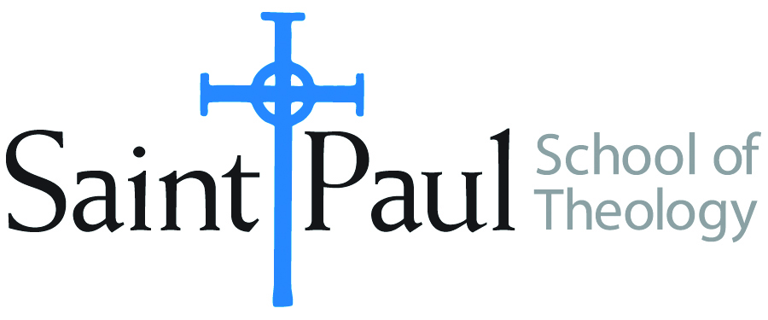
COURSE TEXTBOOK LIST INFORMATION

FACULTY INSTRUCTIONS |  |  | STUDENT INSTRUCTIONS (Both Campuses)
For each semester taught, faculty should complete and submit a new form for every course and return to Joshua Farrell in the Academic Life office. The due dates are September 1 for the following Spring and Summer, and February 1 for the following Fall and Winter. If books are needed in the bookstore at an earlier date than normal, please give exact date in the “Special Instructions” section. Due to limited space, Cokesbury may only have books on hand for the current and upcoming semesters. Desk copies for Teaching Assistants must be requested on this form. It is up to the publishers’ discretion whether or not to provide desk copies for teaching assistants. |  |  | Students may acquire textbooks by ordering online via Amazon Associate on our website and having books shipped to them. Regardless of shopping/ordering method, students may check Cokesbury online for discount on text and certain text may be sent free delivery.
COURSE INSTRUCTOR(S) | Israel Kamudzandu
COURSE NUMBER & SECTION | NTS 458
COURSE NAME | Biblical Hermeneutics: For Clergy Formation
COURSE SEMESTER &YEAR | Fall 2017
DATE OF SUBMISSION | March 20, 2017

REQUIRED TEXTBOOKS LIST
BOOK TITLE and EDITION  (include subtitle if applicable) |  | AUTHOR(S) | No. of  PAGES to be read | PUBLISHER and DATE | 13-Digit ISBN  (without dashes) | LIST PRICE  (estimate) | DESK COPY
1 | A Short History of the Interpretation of the Bible. | Robert M. Grant with David Tracy | 187 | Minneapolis: Fortress Press, 1988 | 9780800617622 | $ 4.20
2 | The Theological Interpretation of Scripture: Classic and Contemporary Readings. | Fowl, Stephen E., ed. | 200 | London: Blackwell, 1997 | 9781557868350 | $21.99
3 | The Art of Reading Scripture. | Davis, Ellen and B. Hays, eds | 100 | Grand Rapids: Eerdmans, 2003 | 9780802812698 | $26.44
5 | Hermeneutics: Principles and Processes of Biblical Interpretation. | Henry A. Virkler and Kareltynne Gerber Ayayo, eds. | 225 | Grand Rapids: Baker Academic, 2007 | 9780801031380 | $10.91 (used)
6 | Elements of Biblical Exegesis, Revised and Expanded edition | Michael Gorman | 167 | Grand Rapids: baker Academic, 2008 | 9780801046407 | $15.99
 | TOTAL Number of Pages to Be Read |  | 876

RECOMMENDED TEXTBOOKS LIST
BOOK TITLE and EDITION  (include subtitle if applicable) |  | AUTHOR(S) | No. of  PAGES to be read | PUBLISHER and DATE | 13-Digit ISBN  (without dashes) | LIST PRICE  (estimate) | DESK COPIES
1 |  |  |  |  |  | $
 | TOTAL Number of Pages to Be Read |  | 876

