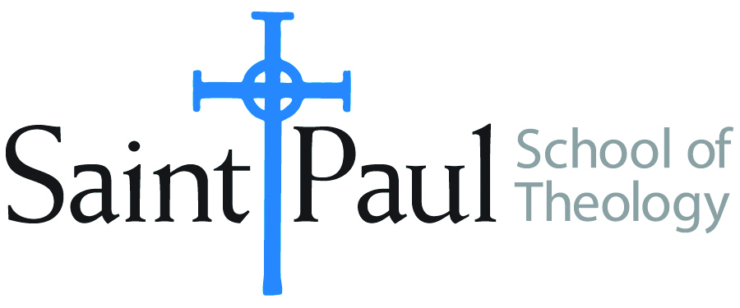
COURSE TEXTBOOK LIST INFORMATION

FACULTY INSTRUCTIONS |  |  | STUDENT INSTRUCTIONS  (Both Campuses)
For each semester taught, faculty should complete and submit a new form for every course and return to Melissa Whalen in the Academic Life office. Forms are due by the first day of registration for a given term. Desk copies for Teaching Assistants must be requested on this form. It is up to the publishers’ discretion whether or not to provide desk copies for teaching assistants. |  |  | Students may acquire textbooks by ordering online via Amazon Associate on our website and having books shipped to them. Regardless of shopping/ordering method, students may check Cokesbury online for discount on text and certain text may be sent free delivery.
COURSE INSTRUCTOR(S) | Patricia B. Jung
COURSE NUMBER & SECTION | ETH 301 AKE & BKE
COURSE NAME | Introduction to Christian Ethics
COURSE SEMESTER &YEAR | Fall 2017
DATE OF SUBMISSION | March 17, 2017

REQUIRED TEXTBOOKS LIST
BOOK TITLE and EDITION  (include subtitle if applicable) |  | AUTHOR(S) | No. of  PAGES to be read | PUBLISHER and DATE | 13-Digit ISBN  (without dashes) | LIST PRICE  (estimate) | DESK COPY
1 | A Textbook of Christian Ethics, 4th ed. | Gill, Robin. | 250 | London: T & T Clark. (2014). | 9780567595928 | $35
2 | Womanist Theological Ethics: A Reader. | Cannon, Katie Geneva, Emilie M. Townes and Angela D. Sims, eds. | 150 | Louisville, KY: Westminster John Knox (2011) | 9780664235376 | $25
3 | Asian American Christian Ethics:  Voices, Methods, Issues. | Kao, Grace Y. and Ilsup Ahn, eds. | 150 | Waco, TX: Baylor University Press (2015) | 9781481301756 | $25
4 | Methodist Morals: Social Principles in the Public Church’s Witness | Darryl W. Stephens | 225 | University of Tennessee Press, 2016 | 9781621902409 | $45
5
6
7
 | TOTAL Number of Pages to Be Read |  | 775

Special Instructions to Cokesbury:

