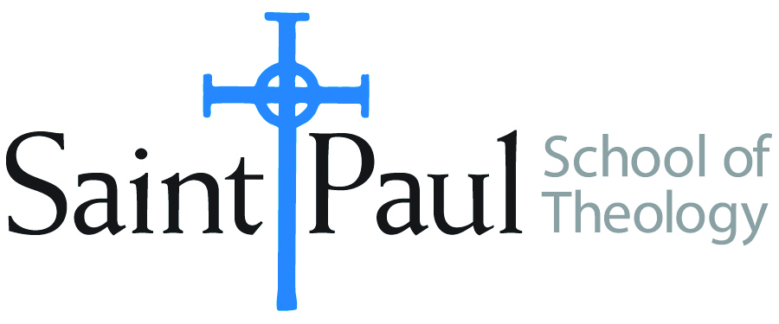
COURSE TEXTBOOK LIST INFORMATION

FACULTY INSTRUCTIONS |  |  | STUDENT INSTRUCTIONS  (Both Campuses)
For each semester taught, faculty should complete and submit a new form for every course and return to Melissa Whalen in the Academic Life office. Forms are due by the first day of registration for a given term. Desk copies for Teaching Assistants must be requested on this form. It is up to the publishers’ discretion whether or not to provide desk copies for teaching assistants. |  |  | Students may acquire textbooks by ordering online at the Cokesbury Virtual Bookstore and having books shipped to them. Regardless of shopping/ordering method, students may be eligible for a clergy discount by ordering through Cokesbury!  Abingdon Press textbook titles are 35% off in the store.  Textbook lists will be available online at http://www.spst.edu/registrar/coursematerial
COURSE INSTRUCTOR(S) | Kris Kvam
COURSE NUMBER & SECTION | THL 430
COURSE NAME | Christian Doctrine: Theological Anthropology
COURSE SEMESTER &YEAR | Spring 2017
DATE OF SUBMISSION | October 6, 2016

REQUIRED TEXTBOOKS LIST
BOOK TITLE and EDITION  (include subtitle if applicable) |  | AUTHOR(S) | No. of  PAGES to be read | PUBLISHER and DATE | 13-Digit ISBN  (without dashes) | LIST PRICE  (estimate) | DESK COPY
1 | Bible, any translation |  |  |  |  |  | no
2 | Creation and Fall: A Theological Exploration of Genesis 1—3; Dietrich Bonhoeffer Works, Volume 3 | Bonhoeffer, Dietrich | Circa 145 | Fortress Press,  1997 or 2007 | 9780800683238 | $40 | yes
3 | Feminist Theory and Christian Theology: Cartographies of Grace, Guides to Theological Inquiry Series. | Jones, Serene | Circa 125 | Fortress Press, 2000 | 9780800626945 | $25 | yes
4 | Eve and Adam: Jewish, Christian, and Muslim Readings on Genesis and Gender | Kvam, Kristen, et alia, ed. | Circa 300 | Indiana University Press, 1999 | 9780253212719 | $30 | yes
5 | Do No Harm: Social Sin and Christian Responsibility | Ray, Stephen | Circa 135 | Fortress Press, 2003 | 9780800634971 | $20 | yes
6 | Enticed by Eden: How Western Culture Uses, Confuses, (and Sometimes Abuses) Adam and Eve | Schearing, Linda, and Valarie Ziegler | Circa 150 | Baylor University Press, 2013 | 9781602585430 | $30 | yes
7
 | TOTAL Number of Pages to Be Read |  | Circa 855

RECOMMENDED TEXTBOOKS LIST
BOOK TITLE and EDITION  (include subtitle if applicable) |  | AUTHOR(S) | No. of  PAGES to be read | PUBLISHER and DATE | 13-Digit ISBN  (without dashes) | LIST PRICE  (estimate) | DESK COPY
1 | God and the Rhetoric of Sexuality (Overtures to Biblical Theology series) | Trible, Phyllis |  | Fortress Press, 1986 | 9780800604646 | $25 | yes
2 | Confessing Our Faith Together: A Study and Discussion Guide | The United Methodist Church and the Evangelical Lutheran Church in America |  | Download from elca.org or umc.org |  |  | no
3
4

Special Instructions to Cokesbury:

