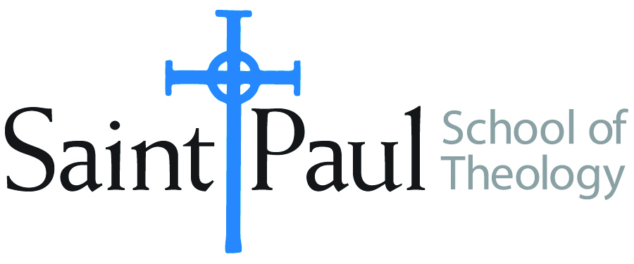
COURSE TEXTBOOK LIST INFORMATION

FACULTY INSTRUCTIONS |  |  | STUDENT INSTRUCTIONS  (Both Campuses)
For each semester taught, faculty should complete and submit a new form for every course and return to Melissa Whalen in the Academic Life office. Forms are due by the first day of registration for a given term. Desk copies for Teaching Assistants must be requested on this form. It is up to the publishers’ discretion whether or not to provide desk copies for teaching assistants. |  |  | Students may acquire textbooks by ordering online at the Cokesbury Virtual Bookstore and having books shipped to them. Regardless of shopping/ordering method, students may be eligible for a clergy discount by ordering through Cokesbury!  Abingdon Press textbook titles are 35% off in the store.  Textbook lists will be available online at http://www.spst.edu/registrar/coursematerial
COURSE INSTRUCTOR(S) | Amy Oden
COURSE NUMBER & SECTION | SFR 502
COURSE NAME | Spiritual Formation Seminar
COURSE SEMESTER &YEAR | Spring 2017
DATE OF SUBMISSION | Sept 26, 2016

REQUIRED TEXTBOOKS LIST
BOOK TITLE and EDITION  (include subtitle if applicable) |  | AUTHOR(S) | No. of  PAGES to be read | PUBLISHER and DATE | 13-Digit ISBN  (without dashes) | LIST PRICE  (estimate) | DESK COPY
1 | The Art of Prayer: An Orthodox Anthology | Igumen Chariton | 220 | Farrar, Strauss and Giroux 1997 | 9780571191659 | 14.00 | 1
2 | Francis of Assisi: Performing the Gospel Life. | Lawrence Cunningham | 170 | Eerdmans, 2004 | 9780802827623 | 14.00 | 1
3 | Christian Prayer for Today | Martha L. Moore-Keish | 104 | Westminster John Knox, 2009 | 978-0664230746 | 12.00 | 1
4 | Worship and Spirituality | Don E. Saliers | 90 | OSL Publications, 2016 | 9781878009272 | 17.00 | 1
5 | An Altar in the World: A Geography of Faith | Barbara Brown Taylor | 240 | HarperOne, 2009 | 9780061370472 | 10.00 | 1
6 | The Orthodox Understanding of Salvation: “Theosis” in Scripture and Tradition | Christopher Veniamin | 150 | Mount Thabor Publishing, 2016 | 9780980020748 | 10.00 | 1
7 | Praying with Body and Soul: A Way to Intimacy with God | Vennard, Jane E. | 138 | Augsburg Press, 1998 | 9780806636146 | 14.00 | 1
8 | The Lady of the Angels and Her City: A Marian Pilgrimage | Wendy M. Wright | 264 | Liturgical Press, 2013 | 9780814634707 | 20.00 | 1
 | TOTAL Number of Pages to Be Read |  | 1386

