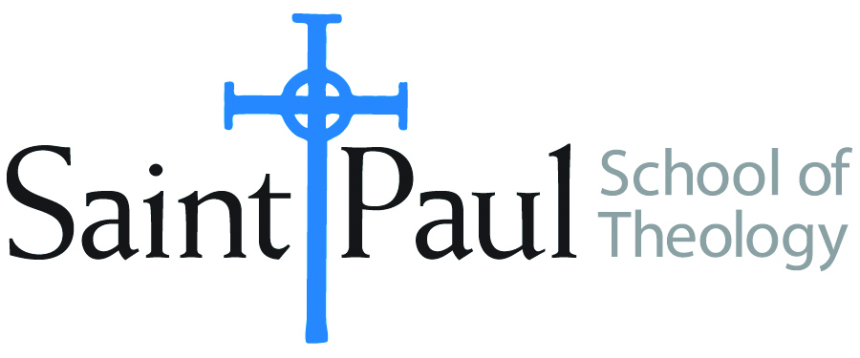
COURSE TEXTBOOK LIST INFORMATION

FACULTY INSTRUCTIONS |  |  | STUDENT INSTRUCTIONS  (Both Campuses)
For each semester taught, faculty should complete and submit a new form for every course and return to Melissa Whalen in the Academic Life office. Forms are due by the first day of registration for a given term. Desk copies for Teaching Assistants must be requested on this form. It is up to the publishers’ discretion whether or not to provide desk copies for teaching assistants. |  |  | Students may acquire textbooks by ordering online at the Cokesbury Virtual Bookstore and having books shipped to them. Regardless of shopping/ordering method, students may be eligible for a clergy discount by ordering through Cokesbury!  Abingdon Press textbook titles are 35% off in the store.  Textbook lists will be available online at http://www.spst.edu/registrar/coursematerial
COURSE INSTRUCTOR(S) | Casey T. Sigmon
COURSE NUMBER & SECTION | PRE 444
COURSE NAME | The Ministry of Preaching in a Digital Age
COURSE SEMESTER &YEAR | Spring 2017
DATE OF SUBMISSION | September 22, 2016

REQUIRED TEXTBOOKS LIST
BOOK TITLE and EDITION  (include subtitle if applicable) |  | AUTHOR(S) | No. of  PAGES to be read | PUBLISHER and DATE | 13-Digit ISBN  (without dashes) | LIST PRICE  (estimate) | DESK COPY
1 | Networked Theology: Negotiating Faith in Digital Culture | Heidi A. Campbell & Stephen Gardner | 147 | Baker Academic, 2016 | 9780801049149 | 22.19
2 | The Social Media Gospel: Sharing the Good News in New Ways | Meredith Gould | 137 | Liturgical Press, 2015 | 9780814635582 | 19.95
3 | Preaching in an Age of Globalization | Eunjoo Mary Kim | 148 | Westminster John Knox, 2010 | 9780664233693 | 25
 | TOTAL Number of Pages to Be Read |  | 432

RECOMMENDED TEXTBOOKS LIST
BOOK TITLE and EDITION  (include subtitle if applicable) |  | AUTHOR(S) | No. of  PAGES to be read | PUBLISHER and DATE | 13-Digit ISBN  (without dashes) | LIST PRICE  (estimate) | DESK COPY
1 | Thy Kingdom Connected | Dwight J. Friesen | 40 | BakerBooks, 2009 | 9780801071638 | 14.99
2 | The Digital Cathedral | Keith Anderson | 40 | Morehouse publishing, 2015 | 9780819229953 | 28.00
3 | I Refuse to Peach a Boring Sermon! | Karyn L. Wiseman | 40 | The Pilgrim Press, 2013 | 9780829819564 | 17

Special Instructions to Cokesbury:

