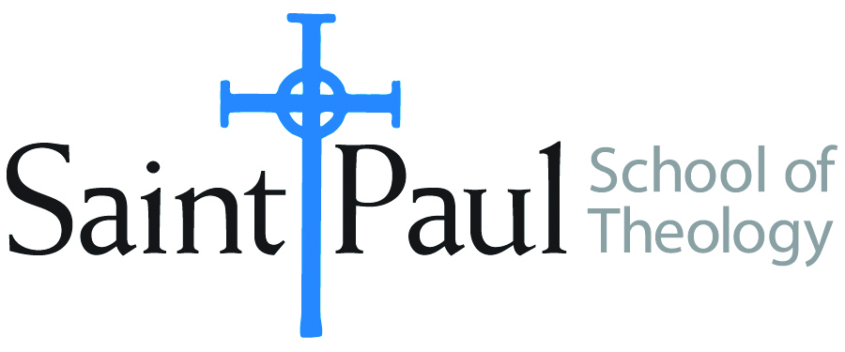
COURSE TEXTBOOK LIST INFORMATION

FACULTY INSTRUCTIONS |  |  | STUDENT INSTRUCTIONS  (Both Campuses)
For each semester taught, faculty should complete and submit a new form for every course and return to Melissa Whalen in the Academic Life office. Forms are due by the first day of registration for a given term. Desk copies for Teaching Assistants must be requested on this form. It is up to the publishers’ discretion whether or not to provide desk copies for teaching assistants. |  |  | Students may acquire textbooks by ordering online at the Cokesbury Virtual Bookstore and having books shipped to them. Regardless of shopping/ordering method, students may be eligible for a clergy discount by ordering through Cokesbury!  Abingdon Press textbook titles are 35% off in the store.  Textbook lists will be available online at http://www.spst.edu/registrar/coursematerial
COURSE INSTRUCTOR(S) | Kris Kvam
COURSE NUMBER & SECTION | Min 340 & Min 341
COURSE NAME | Women, Society, and Church Studies Seminar
COURSE SEMESTER &YEAR | Spring 2016
DATE OF SUBMISSION | 10/11/16

REQUIRED TEXTBOOKS LIST
BOOK TITLE and EDITION  (include subtitle if applicable) |  | AUTHOR(S) | No. of  PAGES to be read | PUBLISHER and DATE | 13-Digit ISBN  (without dashes) | LIST PRICE  (estimate) | DESK COPY
1 | Texts of Terror: Literary-Feminist Readings of Biblical Narratives (Overtures to Biblical Theology) | Phyllis Trible | 100-128 | Fortress Press, 1987 | 9780800615376 | $15 | Yes
2 | A Study Resource for the Film ‘Miss Representation’ | ELCA Task Force on Women and Justice: One in Christ | 12 | http://download.elca.org/ELCA%20Resource%20Repository/Miss_Representation_Discussion_Guide_Option_C.pdf?_ga=1.187136044.505668929.1476214520 |  |  | No
8
 | TOTAL Number of Pages to Be Read

RECOMMENDED TEXTBOOKS LIST
1

Special Instructions to Cokesbury:

