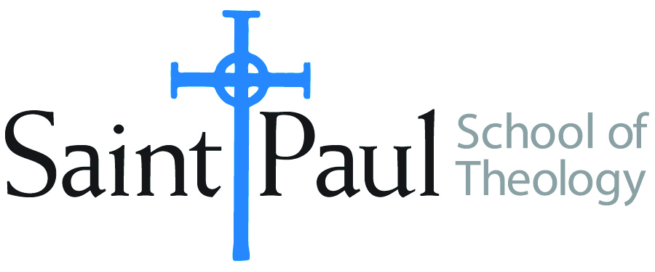
COURSE TEXTBOOK LIST INFORMATION

FACULTY INSTRUCTIONS |  |  | STUDENT INSTRUCTIONS (Both Campuses)
For each semester taught, faculty should complete and submit a new form for every course and return to Megan Temchin in the Academic Life office. Forms are due by the first day of registration for a given term. Desk copies for Teaching Assistants must be requested on this form. It is up to the publishers’ discretion whether or not to provide desk copies for teaching assistants. |  |  | Students may acquire textbooks by ordering online at the Cokesbury Virtual Bookstore and having books shipped to them. Regardless of shopping/ordering method, students may be eligible for a clergy discount by ordering through Cokesbury!  Abingdon Press textbook titles are 35% off in the store.  Textbook lists will be available online at http://www.spst.edu/registrar/coursematerial
COURSE INSTRUCTOR(S) | Linda King
COURSE NUMBER & SECTION | MIN 230 AOV-2017
COURSE NAME | Introduction to Theological Writing
COURSE SEMESTER &YEAR | Spring 2017
REQUIRED TEXTBOOKS LIST
BOOK TITLE and EDITION  (include subtitle if applicable) |  | AUTHOR(S) | No. of  PAGES to be read | PUBLISHER and DATE | 13-Digit ISBN  (without dashes) | LIST PRICE  (est.) | DESK COPY
1 | How To Think Theologically, 2nd ed. | Howard W. Stone & James O. Duke | 140 | Fortress Press, 2006 | 9780800638184 | $14.86
2 | A Manual for Writers of Term Papers, Theses, and Dissertations, 7th ed. | Kate L. Turabian | 100 | University of Chicago Press, 2007 | 9780226823379 | $11.30
 | TOTAL Number of Pages to Be Read |  | 240

RECOMMENDED TEXTBOOKS LIST
BOOK TITLE and EDITION  (include subtitle if applicable) |  | AUTHOR(S) | No. of  PAGES to be read | PUBLISHER and DATE | 13-Digit ISBN  (without dashes) | LIST PRICE  (estimate) | DESK COPY
1
2
3
4

Special Instructions to Cokesbury:

