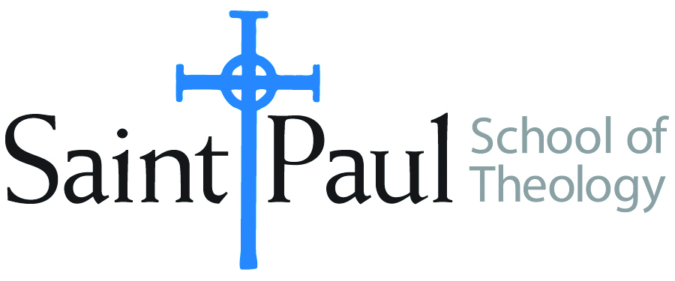
COURSE TEXTBOOK LIST INFORMATION

FACULTY INSTRUCTIONS |  |  | STUDENT INSTRUCTIONS (Both Campuses)
For each semester taught, faculty should complete and submit a new form for every course and return to Joshua Farrell in the Academic Life office. The due dates are September 1 for the following Spring and Summer, and February 1 for the following Fall and Winter. If books are needed in the bookstore at an earlier date than normal, please give exact date in the “Special Instructions” section. Due to limited space, Cokesbury may only have books on hand for the current and upcoming semesters. Desk copies for Teaching Assistants must be requested on this form. It is up to the publishers’ discretion whether or not to provide desk copies for teaching assistants. |  |  | Students may acquire textbooks by shopping at their campus Cokesbury store (in person, by email, or by fax), or by ordering online at the Cokesbury Virtual Bookstore and having books shipped to them. Regardless of shopping/ordering method, students may be eligible for a clergy discount by ordering through Cokesbury!  Textbook lists will be available online at http://www.spst.edu/advance-assignments-booklists.
COURSE INSTRUCTOR(S) | Hal Knight
COURSE NUMBER & SECTION | DST 313
COURSE NAME | John Wesley and the Movements of the Spirit
COURSE SEMESTER &YEAR | Spring, 2017
DATE OF SUBMISSION | 8-28-16

REQUIRED TEXTBOOKS LIST
BOOK TITLE and EDITION  (include subtitle if applicable) |  | AUTHOR(S) | No. of  PAGES to be read | PUBLISHER and DATE | 13-Digit ISBN  (without dashes) | LIST PRICE  (estimate) |  | DESK COPIES
1 | John Wesley’s Sermons: An Anthology | Albert C. Outler/Richard P. Heitzenrater, eds | 267 | Abingdon 1991 | 9780687204953 |  | $19
2 | Practical Divinity, Vol. 1 | Thomas Langford | 250 | Abingdon 1998 | 9780687073825 |  | $26
3 | Responsible Grace* | Randy L. Maddox | 241 | Abingdon 1994 | 9780687003341 |  | $28
4 | The Theology of John Wesley* | Kenneth J. Collins | 331 | Abingdon 2007 | 978068764633 |  | $25
5 | Anticipating Heaven Below | Henry H. Knight III | 250 | Wipf & Stock 2014 | 9781620329603 |  | $25
6 | From Aldersgate to Azusa Street | Henry H. Knight III | 364 | Wipf and Stock 2010 | 9781606089880 |  | $38
7
8
 | TOTAL Number of Pages to Be Read |  | 1372 or 1462
*Students will choose to read EITHER the Maddox or Collins book.
Only portions of the Sermons are assigned
RECOMMENDED TEXTBOOKS LIST
BOOK TITLE and EDITION  (include subtitle if applicable) |  | AUTHOR(S) | No. of  PAGES to be read | PUBLISHER and DATE | 13-Digit ISBN  (without dashes) | LIST PRICE  (estimate) | DESK COPIES
1 | The Theological Roots of Pentecostalism | Donald Dayton | 137 | Hendrickson 1987 | 9780943575797 | $16

