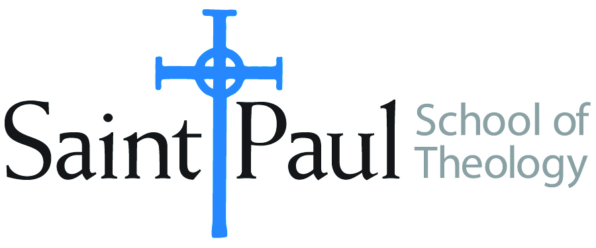
COURSE TEXTBOOK LIST INFORMATION

FACULTY INSTRUCTIONS |  |  | STUDENT INSTRUCTIONS  (Both Campuses)
For each semester taught, faculty should complete and submit a new form for every course and return to Melissa Whalen in the Academic Life office. Forms are due by the first day of registration for a given term. Desk copies for Teaching Assistants must be requested on this form. It is up to the publishers’ discretion whether or not to provide desk copies for teaching assistants. |  |  | Students may acquire textbooks by ordering online at the Cokesbury Virtual Bookstore and having books shipped to them. Regardless of shopping/ordering method, students may be eligible for a clergy discount by ordering through Cokesbury!  Abingdon Press textbook titles are 35% off in the store.  Textbook lists will be available online at http://www.spst.edu/registrar/coursematerial
COURSE INSTRUCTOR(S) | Dr. Yoo Sung-Jun
COURSE NUMBER & SECTION | DMIN 529
COURSE NAME | “Authentic Church”
COURSE SEMESTER &YEAR | Fourth Track Program in February, 2017
DATE OF SUBMISSION

REQUIRED TEXTBOOKS LIST
BOOK TITLE and EDITION  (include subtitle if applicable) |  | AUTHOR(S) | No. of  PAGES to be read | PUBLISHER and DATE | 13-Digit ISBN  (without dashes) | LIST PRICE  (estimate) | DESK COPY
1 | THE STORY OF THE CHURCH OF THE SAVIOR. [IN KOREAN]  미국을 움직이는 작은 공동체 세이비어 교회 / 평단문화사 | YOO SUNG-JUN |  | SEOUL: PYONGDAN PRESS, 2005 | 9788973432158 | 10,000원
2 | SERVANT LEADERSHIP: SERVE LIKE JESUS [IN KOREAN]  예수처럼 섬겨라 / 평단문화사 | YOO SUNG-JUN |  | SEOUL: PYONGDAN PRESS, 2009 | 9788973433070 | 12,000원
3 | THE SMALL COMMUNITY IS HOPE FOR LEADING THE AUTHENTIC CHURCH. [IN KOREAN]  (참된 교회를 이끄는) 작은 공동체가 희망이다 | YOO SUNG-JUN |  | KMC PRESS, 2012 | 9788984305755 | 12,000원
4 | LIFE CAUGHT UP IN THE POWER OF GREAT LOVE  위대한 사랑의 힘에 사로잡힌 삶: 세이비어 교회 창립자 고든 코스비의 묵상집 / 평단문화사 | GORDON COSBY  TRANS. BY YOO SUNG-JUN |  | SEOUL: PYONGDAN PRESS, 2015 | 9788973434114 | 10,000원
5
6
7
 | TOTAL Number of Pages to Be Read

