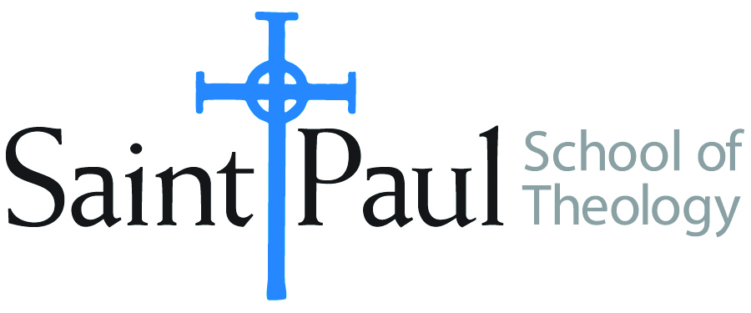
COURSE TEXTBOOK LIST INFORMATION

FACULTY INSTRUCTIONS |  |  | STUDENT INSTRUCTIONS  (Both Campuses)
For each semester taught, faculty should complete and submit a new form for every course and return to Melissa Whalen in the Academic Life office. Forms are due by the first day of registration for a given term. Desk copies for Teaching Assistants must be requested on this form. It is up to the publishers’ discretion whether or not to provide desk copies for teaching assistants. |  |  | Students may acquire textbooks by ordering online at the Cokesbury Virtual Bookstore and having books shipped to them. Regardless of shopping/ordering method, students may be eligible for a clergy discount by ordering through Cokesbury!  Abingdon Press textbook titles are 35% off in the store.  Textbook lists will be available online at http://www.spst.edu/registrar/coursematerial
COURSE INSTRUCTOR(S) | DR. CHUN YOUNG-HO
COURSE NUMBER & SECTION | DMIN 527
COURSE NAME | " ENACTING WESLEYAN THEOLOGY”
COURSE SEMESTER &YEAR | Fourth Track Program in February, 2017
DATE OF SUBMISSION

REQUIRED TEXTBOOKS LIST
BOOK TITLE and EDITION  (include subtitle if applicable) |  | AUTHOR(S) | No. of  PAGES to be read | PUBLISHER and DATE | 13-Digit ISBN  (without dashes) | LIST PRICE  (estimate) | DESK COPY
1 | JOHN WESLEY'S TEACHING, VOL. I | THOMAS ODEN |  | ZONDERVAN PRESS, 2012 | 9780310328155 | $17.50
2 | JOHN WESLEY'S TEACHING, VOL. II | THOMAS ODEN |  | ZONDERVAN PRESS, 2012 | 9780310492672 | $22.99
3 | CALVIN VS. WESLEY: BRINGING BELIEF IN LINE WITH PRACTICE | DON THORSEN |  | NASHVILLE: ABINGDON PRESS, 2013 | 9781426743351 | $14.88
4 | THE HOLY TRINITY—GOD FOR GOD AND GOD FOR US. [IN KOREAN]  내재적 삼위일체와 경륜적 삼위일체:현대 삼위일체신학에 대한 신학 철학의 융합적 분석 / 새물결플러스 | PAIK CHOONG-HYUN |  | SEOUL: HOLY WAVE PLUS PUBLISHING CO., 2015 | 9791186409350 | 16,000원
5 | THEOLOGICAL LECTURES FOR THE MODERNS: 12 THEMES. [IN KOREAN]  현대인을 위한 신학강의: 12개의 주제 / 대한기독교서회 | KIM DONG-KEUN |  | SEOUL: KOREAN CHRISTIAN LITERATURE SOCIETY, 2011 | 9788951114069 | 12,800원
6 | AFTER OUR LIKENESS  삼위일체와 교회: 하나님의 형상으로서 교회에 대한 가톨릭 동방 정교회 개신교적 이해를 찾아서 / 새물결플러스 | MIROSLAV VOLF,. TRANS. BY HWANG EUN-YOUNG |  | SEOUL: HOLY WAVE PLUS PUBLISHING CO., 2012 | 9788994752211 | 28,000원
 | TOTAL Number of Pages to Be Read

