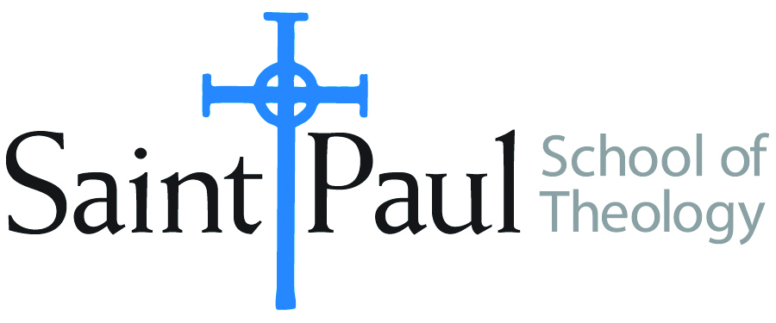
COURSE TEXTBOOK LIST INFORMATION

FACULTY INSTRUCTIONS |  |  | STUDENT INSTRUCTIONS  (Both Campuses)
For each semester taught, faculty should complete and submit a new form for every course and return to Ethel Tomlinson, Registrar Clerk. Forms are due by the first day of registration for a given term. Desk copies for Teaching Assistants must be requested on this form. It is up to the publishers’ discretion whether or not to provide desk copies for teaching assistants. |  |  | Students may acquire textbooks by ordering online at the Cokesbury Virtual Bookstore and having books shipped to them. Regardless of shopping/ordering method, students may be eligible for a clergy discount by ordering through Cokesbury!  Abingdon Press textbook titles are 35% off in the store.
COURSE INSTRUCTOR(S) | Anne Walker
COURSE NUMBER & SECTION | CRE 386: Teaching and Learning: Lifelong Process
COURSE NAME
COURSE SEMESTER &YEAR | Spring 2017
DATE OF SUBMISSION | 10/16/016

REQUIRED TEXTBOOKS LIST
BOOK TITLE and EDITION  (include subtitle if applicable) |  | AUTHOR(S) | No. of  PAGES to be read | PUBLISHER and DATE | 13-Digit ISBN  (without dashes) | LIST PRICE  (estimate) | DESK COPY
1 | Teaching as a Sacramental Act | Moore | 256 | Pilgrim, 2004 | 9780829816471 | 15.93
2 | The Courage to Teach | Palmer | 272 | Jossey-Bass, 2007 | 9780787996864 | 19.12 | X
3 | Critical Minds and Discerning Hearts | Talvacchia | 112 | Chalice, 2003 | 9780827204911 | 10.97
4
5
6
7
 | TOTAL Number of Pages to Be Read

RECOMMENDED TEXTBOOKS LIST
BOOK TITLE and EDITION  (include subtitle if applicable) |  | AUTHOR(S) | No. of  PAGES to be read | PUBLISHER and DATE | 13-Digit ISBN  (without dashes) | LIST PRICE  (estimate) | DESK COPY
1
2
3
4

Special Instructions to Cokesbury:

