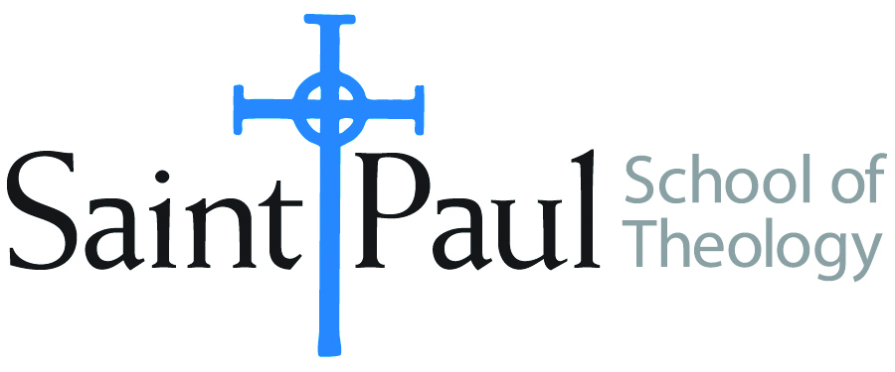
COURSE TEXTBOOK LIST INFORMATION

FACULTY INSTRUCTIONS |  |  | STUDENT INSTRUCTIONS  (Both Campuses)
For each semester taught, faculty should complete and submit a new form for every course and return to Melissa Whalen in the Academic Life office. Forms are due by the first day of registration for a given term. Desk copies for Teaching Assistants must be requested on this form. It is up to the publishers’ discretion whether or not to provide desk copies for teaching assistants. |  |  | Students may acquire textbooks by ordering online at the Cokesbury Virtual Bookstore and having books shipped to them. Regardless of shopping/ordering method, students may be eligible for a clergy discount by ordering through Cokesbury!  Abingdon Press textbook titles are 35% off in the store.  Textbook lists will be available online at http://www.spst.edu/registrar/coursematerial
COURSE INSTRUCTOR(S) | Rodney Newman
COURSE NUMBER & SECTION | SFR 301 AO
COURSE NAME | Spiritual Retreat
COURSE SEMESTER &YEAR | Spring 2017
DATE OF SUBMISSION | November 1, 2016

REQUIRED TEXTBOOKS LIST
BOOK TITLE and EDITION  (include subtitle if applicable) |  | AUTHOR(S) | No. of  PAGES to be read | PUBLISHER and DATE | 13-Digit ISBN  (without dashes) | LIST PRICE  (estimate) | DESK COPY
1
2
3
4
5
6
7
 | TOTAL Number of Pages to Be Read

RECOMMENDED TEXTBOOKS LIST
BOOK TITLE and EDITION  (include subtitle if applicable) |  | AUTHOR(S) | No. of  PAGES to be read | PUBLISHER and DATE | 13-Digit ISBN  (without dashes) | LIST PRICE  (estimate) | DESK COPY
1 | Listening for the Heartbeat of God: A Celtic Spirituality | J. Philip Newell | 112 | Paulist Press 1997 | 9780809137596 | $10.95
2 | Journeys with Celtic Christians | Rodney Newman | 160 | Abingdon Press 2015 | 9781630889814 | $14.99
3
4

Special Instructions to Cokesbury:

