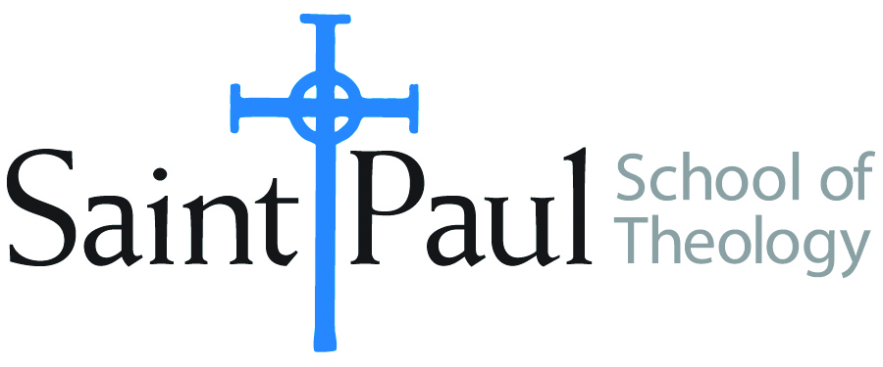
COURSE TEXTBOOK LIST INFORMATION

FACULTY INSTRUCTIONS |  |  | STUDENT INSTRUCTIONS  (Both Campuses)
For each semester taught, faculty should complete and submit a new form for every course and return to Melissa Whalen in the Academic Life office. Forms are due by the first day of registration for a given term. Desk copies for Teaching Assistants must be requested on this form. It is up to the publishers’ discretion whether or not to provide desk copies for teaching assistants. |  |  | Students may acquire textbooks by ordering online at the Cokesbury Virtual Bookstore and having books shipped to them. Regardless of shopping/ordering method, students may be eligible for a clergy discount by ordering through Cokesbury!  Abingdon Press textbook titles are 35% off in the store.  Textbook lists will be available online at http://www.spst.edu/registrar/coursematerial
COURSE INSTRUCTOR(S) | Claire A Smith
COURSE NUMBER & SECTION | PCM 359
COURSE NAME | Praying with Joy in a Troubled World
COURSE SEMESTER &YEAR | Spring 2017
DATE OF SUBMISSION | October 10, 2016

REQUIRED TEXTBOOKS LIST
BOOK TITLE and EDITION  (include subtitle if applicable) |  | AUTHOR(S) | No. of  PAGES to be read | PUBLISHER and DATE | 13-Digit ISBN  (without dashes) | LIST PRICE  (estimate) | DESK COPY
1 | Praying Past Fear: Praying with Joy in a Troubled World | Claire Annelise Smith | 100 | SurrenderInPrayer 2017 | Forthcoming  9780996765558 | 12.95 | No
2 | Soul Feast, Newly Revised Edition: An Invitation to the Christian Spiritual Life | Marjorie Thompson | 100 | Westminster John Knox 2014 | 9780664239244 | 17.00 | Yes
3
4
5
6
7
 | TOTAL Number of Pages to Be Read |  | 200

RECOMMENDED TEXTBOOKS LIST
BOOK TITLE and EDITION  (include subtitle if applicable) |  | AUTHOR(S) | No. of  PAGES to be read | PUBLISHER and DATE | 13-Digit ISBN  (without dashes) | LIST PRICE  (estimate) | DESK COPY
1
2
3
4

Special Instructions to Cokesbury:

