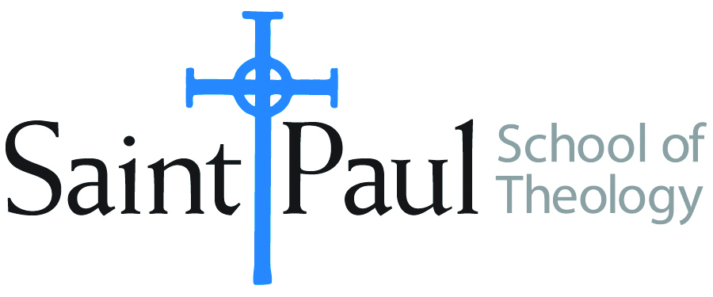
DCOURSE TEXTBOOK LIST INFORMATION

FACULTY INSTRUCTIONS |  |  | STUDENT INSTRUCTIONS  (Both Campuses)
For each semester taught, faculty should complete and submit a new form for every course and return to Melissa Whalen in the Academic Life office. Forms are due by the first day of registration for a given term. Desk copies for Teaching Assistants must be requested on this form. It is up to the publishers’ discretion whether or not to provide desk copies for teaching assistants. |  |  | Students may acquire textbooks by ordering online at the Cokesbury Virtual Bookstore and having books shipped to them. Regardless of shopping/ordering method, students may be eligible for a clergy discount by ordering through Cokesbury!  Abingdon Press textbook titles are 35% off in the store.  Textbook lists will be available online at http://www.spst.edu/registrar/coursematerial
COURSE INSTRUCTOR(S) | Kyle Butler
COURSE NUMBER & SECTION | HST 514
COURSE NAME | Spiritual Traditions and Ministry
COURSE SEMESTER &YEAR | Spring 2017
DATE OF SUBMISSION | 10/25/16

REQUIRED TEXTBOOKS LIST
BOOK TITLE and EDITION  (include subtitle if applicable) |  | AUTHOR(S) | No. of  PAGES to be read | PUBLISHER and DATE | 13-Digit ISBN  (without dashes) | LIST PRICE  (estimate) | DESK COPY
1 | Streams of Living Water | Foster, Richard | 272 | HarperOne, 1998, 2001 | 9780060628222 | 15.99
2 | Places of Redemption: Theology for a Worldly Church | Fulkerson, Mary McClintock | 254 | Oxford, 2007 | 9780199296477 | 38.95
3 | Art of Memoir | Karr, Mary | 218 | HarperCollins, 2015, 2016 | 9780062223074 | 15.99
4 | Searching for Sunday | Held Evans, Rachel | 258 | Nelson Books, 2015 | 9780718022129 | 16.99
5
6
7
 | TOTAL Number of Pages to Be Read |  | 1,002

RECOMMENDED TEXTBOOKS LIST
BOOK TITLE and EDITION  (include subtitle if applicable) |  | AUTHOR(S) | No. of  PAGES to be read | PUBLISHER and DATE | 13-Digit ISBN  (without dashes) | LIST PRICE  (estimate) | DESK COPY
1
2
3
4

Special Instructions to Cokesbury:

