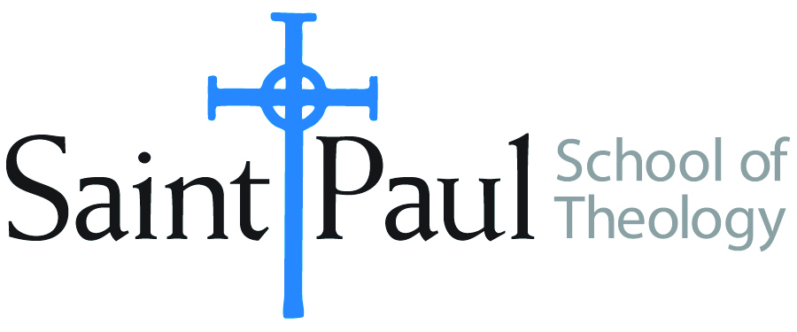
COURSE TEXTBOOK LIST INFORMATION

FACULTY INSTRUCTIONS |  |  | STUDENT INSTRUCTIONS  (Both Campuses)
For each semester taught, faculty should complete and submit a new form for every course and return to Melissa Whalen in the Academic Life office. Forms are due by the first day of registration for a given term. Desk copies for Teaching Assistants must be requested on this form. It is up to the publishers’ discretion whether or not to provide desk copies for teaching assistants. |  |  | Students may acquire textbooks by ordering online via Amazon Associate on our website and having books shipped to them. Regardless of shopping/ordering method, students may check Cokesbury online for discount on text and certain text may be sent free delivery.
COURSE INSTRUCTOR(S) | Young-Ho Chun
COURSE NUMBER & SECTION | THL 452
COURSE NAME | Minjung Theology and Dalit Theology
COURSE SEMESTER &YEAR | Fall 2017
DATE OF SUBMISSION | 3/24/2017

REQUIRED TEXTBOOKS LIST
BOOK TITLE and EDITION  (include subtitle if applicable) |  | AUTHOR(S) | No. of  PAGES to be read | PUBLISHER and DATE | 13-Digit ISBN  (without dashes) | LIST PRICE  (estimate) | DESK COPY
1 | Minjung Theology: People as.. | CTCCCA | 120 | Orbis Book 1983 | 9780883443361 | 6.49 | Yes
2 | An Emerging Theology in World Perspective: Commentary on… | (ed) Jung Young Lee | 90 | Twenty Third Pub. 1988 | 9780896223783 | 32.98 Used | Yes
3 | Dalit Theology & Dalit Liberation | Peniel Rajkumar | 80 | Ashgate, 2010 | 9780754665137 | 21.00 | Yes
4 | Tamil Folk Music as Dalit Liberation Theology | Zoe Sherinian | 50 | Indiana Univ. Press 2014 | 9780253005854 | 29.00 | Yes
5 | The People and the People of God | Hans Ucko | 50 | Lit Verlag 2002 | 9783825855642 | 14.56 | Yes
6
7
 | TOTAL Number of Pages to Be Read

RECOMMENDED TEXTBOOKS LIST
BOOK TITLE and EDITION  (include subtitle if applicable) |  | AUTHOR(S) | No. of  PAGES to be read | PUBLISHER and DATE | 13-Digit ISBN  (without dashes) | LIST PRICE  (estimate) | DESK COPY
1 | The Korean Minjung in Christ | David K.S. Suh | 80 | Wipf & Stock Pub 2000 | 9781579105099 | 25.00 | Yes
2 | Christianity in Modern Korea | Donald N. Clark | 30 | Univ Press 1986 | 9780819153852 | 20.00 | Yes
3 | Hope Abundant: Third World | Kwok Pui-lan | 50 | Orbis 2010 | 978-1570758805 | 20.37 | Yes
4

Special Instructions to Cokesbury:

