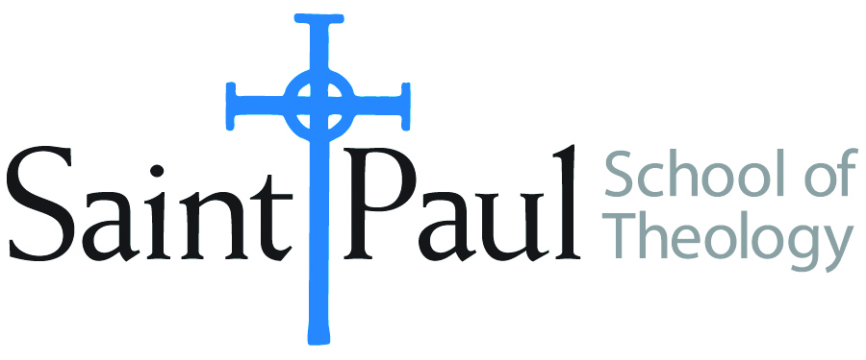
COURSE TEXTBOOK LIST INFORMATION

FACULTY INSTRUCTIONS |  |  | STUDENT INSTRUCTIONS  (Both Campuses)
For each semester taught, faculty should complete and submit a new form for every course and return to Melissa Whalen in the Academic Life office. Forms are due by the first day of registration for a given term. Desk copies for Teaching Assistants must be requested on this form. It is up to the publishers’ discretion whether or not to provide desk copies for teaching assistants. |  |  | Students may acquire textbooks by ordering online via Amazon Associate on our website and having books shipped to them. Regardless of shopping/ordering method, students may check Cokesbury online for discount on text and certain text may be sent free delivery.
COURSE INSTRUCTOR(S) | Dr. Kris Kvam
COURSE NUMBER & SECTION | THL 450
COURSE NAME | Selected Theologian Serene Jones
COURSE SEMESTER &YEAR | Fall 2017
DATE OF SUBMISSION

REQUIRED TEXTBOOKS LIST
BOOK TITLE and EDITION  (include subtitle if applicable) |  | AUTHOR(S) | No. of  PAGES to be read | PUBLISHER and DATE | 13-Digit ISBN  (without dashes) | LIST PRICE  (estimate) | DESK COPY
1 | Feminist Theory and Christian Theology: Cartographies of Grace | Jones, Serene | 205 | Fortress, 2000 | 9780800626945 | 22 | 1
2 | Trauma and Grace: Theology in a Ruptured World | Jones, Serene | 175 | Westminster John Knox, 2009 | 9780664234102 | 22 | 1
3 | “Constructive Theology: A Contemporary Approach to Classical Themes | ed. by Serene Jones and Paul Lakeland | 8-12 | Fortress Press, 2005 | 9780800636838 | 46
4 | “Dear Christians: Stop Opposing . . . LGBTQ | Jones, Serene |  | http://time.com/2954744/dear-christians-stop-opposing-obamas-ban-on-lgbtq-job-discrimination/?iid=sr-link1
5 | How to Heal the Spiritual Pain of America | Jones, Serene |  | http://time.com/4477582/heal-the-spiritual-pain-of-america/?iid=sr-link1
6 | Paris Climate Conference | Jones, Serene |  | http://time.com/4132917/paris-climate-conference-leadership/?iid=sr-link1
7 | Presidential Address to the American Academy of Religion | Jones, Serene
8 | Selling Justice Short | Jones, Serene |  | http://time.com/7359/selling-social-justice-short/?iid=sr-link1
9 | The Original Christmas Story is Really about Refugees | Jones, Serene |  | http://time.com/4155651/christmas-story-refugees/?iid=sr-link1
10 | What Feminist Christians Think about Pope Francis | Jones, Serene |  | http://time.com/4046990/what-feminist-christians-think-about-pope-francis/?iid=sr-link1
 | TOTAL Number of Pages to Be Read

RECOMMENDED TEXTBOOKS LIST
BOOK TITLE and EDITION  (include subtitle if applicable) |  | AUTHOR(S) | No. of  PAGES to be read | PUBLISHER and DATE | 13-Digit ISBN  (without dashes) | LIST PRICE  (estimate) | DESK COPY
1 | Dictionary of Feminist Theologies | Russell and Clarkson, eds. |  | Westminster John Knox, 2004 | 9780664229238 | 33
2
3
4

Special Instructions to Cokesbury:

