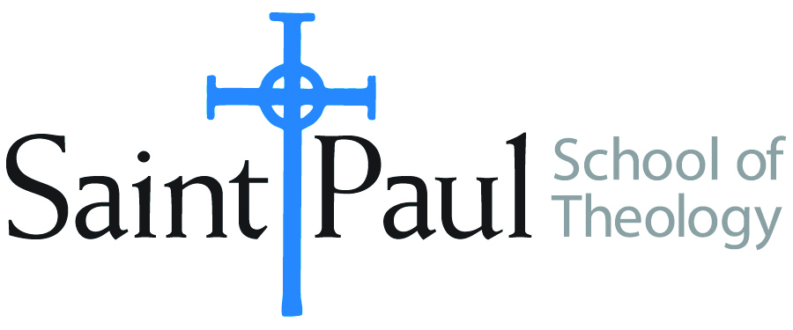
COURSE TEXTBOOK LIST INFORMATION

FACULTY INSTRUCTIONS |  |  | STUDENT INSTRUCTIONS  (Both Campuses)
For each semester taught, faculty should complete and submit a new form for every course and return to Melissa Whalen in the Academic Life office. Forms are due by the first day of registration for a given term. Desk copies for Teaching Assistants must be requested on this form. It is up to the publishers’ discretion whether or not to provide desk copies for teaching assistants. |  |  | Students may acquire textbooks by ordering online via Amazon Associate on our website and having books shipped to them. Regardless of shopping/ordering method, students may check Cokesbury online for discount on text and certain text may be sent free delivery.
COURSE INSTRUCTOR(S) | James Brandt
COURSE NUMBER & SECTION | SFR 503 AOE
COURSE NAME | Spiritual Formation for Ministry III
COURSE SEMESTER &YEAR | Fall 2017
DATE OF SUBMISSION | March 7, 2017

REQUIRED TEXTBOOKS LIST
BOOK TITLE and EDITION  (include subtitle if applicable) |  | AUTHOR(S) | No. of  PAGES to be read | PUBLISHER and DATE | 13-Digit ISBN  (without dashes) | LIST PRICE  (estimate) | DESK COPY
1 | The Spirituality of Jesus: Nine Disciplines Christ Modeled for Us | Hardin, Leslie | 181 | Kregel Publications, 2009. | 9780825429057 | $13 | yes
2 | Spirituality According to Paul: Imitating the Apostle of Christ | Reeves, Rodney | 236 | IVP Academic, 2011 | 9780830839469 | $16 | yes
3 | Practicing our faith : a way of life for a searching people | Dorothy C. Bass, editor | 219 | Jossey-Bass, 2nd ed. 2010 | 9780470484111 | $15 | yes
4
5
6
7
 | TOTAL Number of Pages to Be Read

RECOMMENDED TEXTBOOKS LIST
BOOK TITLE and EDITION  (include subtitle if applicable) |  | AUTHOR(S) | No. of  PAGES to be read | PUBLISHER and DATE | 13-Digit ISBN  (without dashes) | LIST PRICE  (estimate) | DESK COPY
1 | The Spirituality of the Gospels | Barton, Stephen C | 159 | Wipf & Stock, 2005 | 9781597529099 | $22 | no
2
3
4

Special Instructions to Cokesbury:

