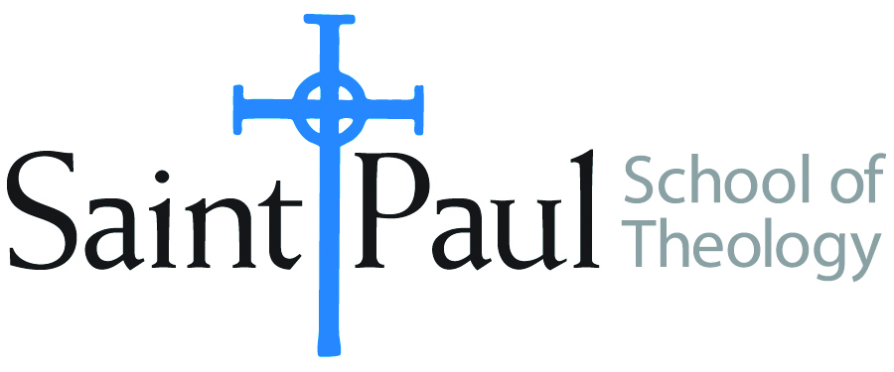
COURSE TEXTBOOK LIST INFORMATION

FACULTY INSTRUCTIONS |  |  | STUDENT INSTRUCTIONS  (Both Campuses)
For each semester taught, faculty should complete and submit a new form for every course and return to Melissa Whalen in the Academic Life office. Forms are due by the first day of registration for a given term. Desk copies for Teaching Assistants must be requested on this form. It is up to the publishers’ discretion whether or not to provide desk copies for teaching assistants. |  |  | Students may acquire textbooks by ordering online via Amazon Associate on our website and having books shipped to them. Regardless of shopping/ordering method, students may check Cokesbury online for discount on text and certain text may be sent free delivery.
COURSE INSTRUCTOR(S) | Graves
COURSE NUMBER & SECTION | PRE 430
COURSE NAME | Sermon and the Short Story
COURSE SEMESTER &YEAR | Fall 2017
DATE OF SUBMISSION | March 3, 2017

REQUIRED TEXTBOOKS LIST
BOOK TITLE and EDITION  (include subtitle if applicable) |  | AUTHOR(S) | No. of  PAGES to be read | PUBLISHER and DATE | 13-Digit ISBN  (without dashes) | LIST PRICE  (estimate) | DESK COPY
1 | The Story of Narrative Preaching | Mike Graves | 244 | Cascade 2015 | 978-1620328736 | 29
2 | Reading Lolita in Tehran | Azar Nafisi | 400 | Random House 2008 | 978-0812979305 | 10
3 | Celestial Omnibus: Short Fiction on Faith | J.P. Maney and Tom Hazuka | 330 | Beacon 1997 | 978-0807083352 | 26
4
5
6
7
 | TOTAL Number of Pages to Be Read |  | 900

RECOMMENDED TEXTBOOKS LIST
BOOK TITLE and EDITION  (include subtitle if applicable) |  | AUTHOR(S) | No. of  PAGES to be read | PUBLISHER and DATE | 13-Digit ISBN  (without dashes) | LIST PRICE  (estimate) | DESK COPY
1
2
3
4

Special Instructions to Cokesbury:

