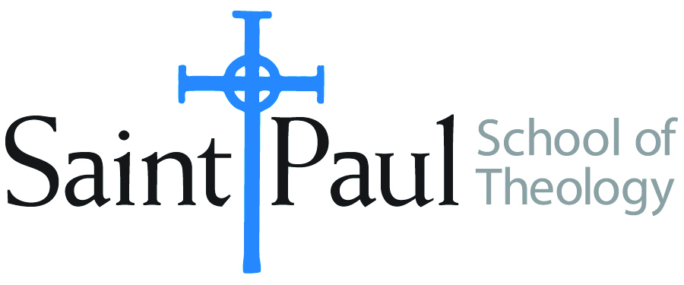
COURSE TEXTBOOK LIST INFORMATION

FACULTY INSTRUCTIONS |  |  | STUDENT INSTRUCTIONS  (Both Campuses)
For each semester taught, faculty should complete and submit a new form for every course and return to Melissa Whalen in the Academic Life office. Forms are due by the first day of registration for a given term. Desk copies for Teaching Assistants must be requested on this form. It is up to the publishers’ discretion whether or not to provide desk copies for teaching assistants. |  |  | Students may acquire textbooks by ordering online via Amazon Associate on our website and having books shipped to them. Regardless of shopping/ordering method, students may check Cokesbury online for discount on text and certain text may be sent free delivery.
COURSE INSTRUCTOR(S) | Dr. Kris Kvam
COURSE NUMBER & SECTION | PCM 342
COURSE NAME | Practicum: Leadership Institute and Doctrinal Reflection
COURSE SEMESTER &YEAR | Fall 2017
DATE OF SUBMISSION | March 10, 2017

REQUIRED TEXTBOOKS LIST
BOOK TITLE and EDITION  (include subtitle if applicable) |  | AUTHOR(S) | No. of  PAGES to be read | PUBLISHER and DATE | 13-Digit ISBN  (without dashes) | LIST PRICE  (estimate) | DESK COPY
1 | The Nature and Mission of the Church | Faith and Order Paper 198 | 35 pages | World Council of Churches, 2005. | Download from WCC’s site: http://www.oikoumene.org/en/resources/documents/commissions/faith-and-order/i-unity-the-church-and-its-mission/the-nature-and-mission-of-the-church-a-stage-on-the-way-to-a-common-statement | None
2 | “The Mission of the Church” in Constructive Theology: A Contemporary Approach to Classic Themes: | Serene Jones and Paul Lakeland | 7 pages | Fortress, 2005 | 9780800636838
3 | Ecclesial Existence, Volume 3 of Christian Community in History, pp. 28-43 and 71-114 | Roger Haight | 60 pages | Continuum, 2008 | 9780826429476
4
5
6
7
 | TOTAL Number of Pages to Be Read |  | 102 pp.

RECOMMENDED TEXTBOOKS LIST
BOOK TITLE and EDITION  (include subtitle if applicable) |  | AUTHOR(S) | No. of  PAGES to be read | PUBLISHER and DATE | 13-Digit ISBN  (without dashes) | LIST PRICE  (estimate) | DESK COPY
1 | The Church Towards a Common Vision | Faith  and Order Paper 214 | 46 pages, | World Council of Churches, 2013. | Download from http://www.oikoumene.org/en/resources/documents/commissions/faith-and-order/i-unity-the-church-and-its-mission/the-church-towards-a-common-vision
2
3
4

Special Instructions to Cokesbury:

