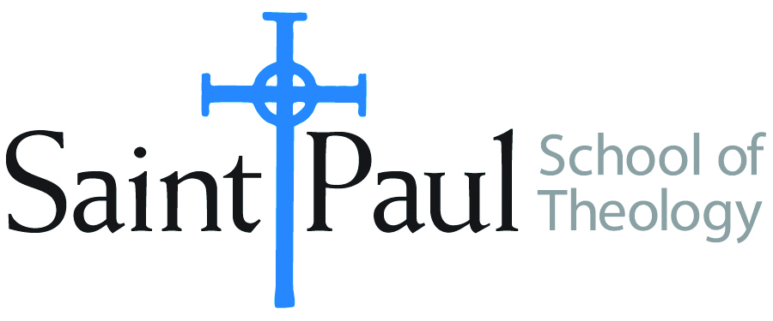
COURSE TEXTBOOK LIST INFORMATION

FACULTY INSTRUCTIONS |  |  | STUDENT INSTRUCTIONS  (Both Campuses)
For each semester taught, faculty should complete and submit a new form for every course and return to Melissa Whalen in the Academic Life office. Forms are due by the first day of registration for a given term. Desk copies for Teaching Assistants must be requested on this form. It is up to the publishers’ discretion whether or not to provide desk copies for teaching assistants. |  |  | Students may acquire textbooks by ordering online via Amazon Associate on our website and having books shipped to them. Regardless of shopping/ordering method, students may check Cokesbury online for discount on text and certain text may be sent free delivery.
COURSE INSTRUCTOR(S) | Harold Washington
COURSE NUMBER & SECTION | HBS 301, A0HV, AOE
COURSE NAME | Introduction to the Hebrew Bible
COURSE SEMESTER &YEAR | Fall 2017
DATE OF SUBMISSION | March 14, 2017

REQUIRED TEXTBOOKS LIST
BOOK TITLE and EDITION  (include subtitle if applicable) |  | AUTHOR(S) | No. of  PAGES to be read | PUBLISHER and DATE | 13-Digit ISBN  (without dashes) | LIST PRICE  (estimate) | DESK COPY
1 | The New Oxford Annotated Bible with Apocrypha: New Revised Standard Version, 4th edition. | Michael D. Coogan, ed. | 450 | Oxford University Press, 2010 | 9780195289602 | $21.14  or ebook $14.39 | Yes,1
2 | A Short Introduction to the Hebrew Bible, 2nd edition | John J. Collins | 245 | Fortress Press, 2014 | 9781451472943 | $43.98 or ebook  $26.49 | Yes, 1
3 | Hidden Riches: A Sourcebook for the Comparative Study of the Hebrew Bible and Ancient Near East | Christopher  B. Hayes | 195 | Westminster/  John Knox Press, 2014 | 9780664237011 | $40.65 or ebook, $15.12 | Yes1
4
5
6
7
 | TOTAL Number of Pages to Be Read |  | 890

RECOMMENDED TEXTBOOKS LIST
BOOK TITLE and EDITION  (include subtitle if applicable) |  | AUTHOR(S) | No. of  PAGES to be read | PUBLISHER and DATE | 13-Digit ISBN  (without dashes) | LIST PRICE  (estimate) | DESK COPY
1
2
3
4

Special Instructions to Cokesbury:

