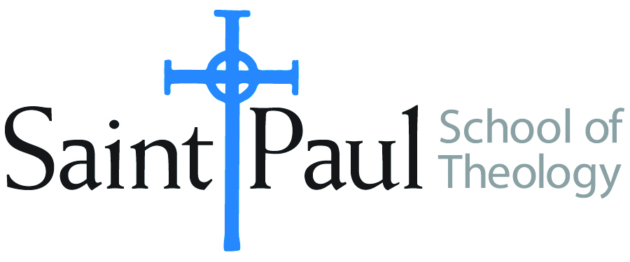
COURSE TEXTBOOK LIST INFORMATION

FACULTY INSTRUCTIONS |  |  | STUDENT INSTRUCTIONS (Both Campuses)
For each semester taught, faculty should complete and submit a new form for every course and return to Joshua Farrell in the Academic Life office. The due dates are September 1 for the following Spring and Summer, and February 1 for the following Fall and Winter. If books are needed in the bookstore at an earlier date than normal, please give exact date in the “Special Instructions” section. Due to limited space, Cokesbury may only have books on hand for the current and upcoming semesters. Desk copies for Teaching Assistants must be requested on this form. It is up to the publishers’ discretion whether or not to provide desk copies for teaching assistants. |  |  | Students may acquire textbooks by shopping at their campus Cokesbury store (in person, by email, or by fax), or by ordering online at the Cokesbury Virtual Bookstore and having books shipped to them. Regardless of shopping/ordering method, students may be eligible for a clergy discount by ordering through Cokesbury!  Abingdon Press textbook titles are 35% off in the store.  Textbook lists will be available online at http://www.spst.edu/registrar/coursematerial
COURSE INSTRUCTOR(S) | Elaine Robinson
COURSE NO & SECTION | DST 310
COURSE NAME | United Methodist History
COURSE SEMESTER &YEAR | Fall 2017
DATE OF SUBMISSION | 3/14/2017

REQUIRED TEXTBOOKS LIST
BOOK TITLE and EDITION  (include subtitle if applicable) |  | AUTHOR(S) | No. of  PAGES to be read | PUBLISHER and DATE | 13-Digit ISBN  (without dashes) | LIST PRICE  (estimate) | DESK COPIES
1 | The Methodist Experience in America: A History, Vol. 1 | Richey, Rowe, and Schmidt | 600 | Abingdon, 2010 | 9780687246724 | $35
2 | Wesley and the People Called Methodists, 2nd ed. | Richard P. Heitzenrater | 300 | Abingdon, 2013 | 9781426742248 | $25
3 | We Shall not be Moved: Methodist Debate Race, Gender, Homosexuality | Nickell, Jane Ellen | 192 | Pickwick, 2014 | 9781625644848 | $22
4 |  |  |  |  |  | $
5 |  |  |  |  |  | $
6 |  |  |  |  |  | $
 | TOTAL Number of Pages to Be Read |  | 1000

RECOMMENDED TEXTBOOKS LIST
BOOK TITLE and EDITION  (include subtitle if applicable) |  | AUTHOR(S) | No. of  PAGES to be read | PUBLISHER and DATE | 13-Digit ISBN  (without dashes) | LIST PRICE  (estimate) | DESK COPIES
1 | The Methodist Experience in America: A Sourcebook, Vol. 2 | Richey, Rowe, and Schmidt |  | Abingdon, 2000 | 9780687246731 | $50
2 | American Methodism: A Compact History | Richey, Rowe, and Schmidt | 260 | Abingdon, 2012 | 9781426742279 | $24
3 |  |  |  |  |  | $
4 |  |  |  |  |  | $
 | TOTAL Number of Pages to Be Read

