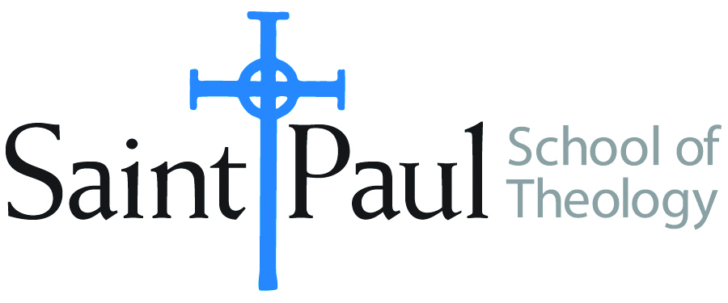
COURSE TEXTBOOK LIST INFORMATION

FACULTY INSTRUCTIONS |  |  | STUDENT INSTRUCTIONS  (Both Campuses)
For each semester taught, faculty should complete and submit a new form for every course and return to Melissa Whalen in the Academic Life office. Forms are due by the first day of registration for a given term. Desk copies for Teaching Assistants must be requested on this form. It is up to the publishers’ discretion whether or not to provide desk copies for teaching assistants. |  |  | Students may acquire textbooks by ordering online via Amazon Associate on our website and having books shipped to them. Regardless of shopping/ordering method, students may check Cokesbury online for discount on text and certain text may be sent free delivery.
COURSE INSTRUCTOR(S) | AnneCarter Walker
COURSE NUMBER & SECTION | CRE 362
COURSE NAME | Faith Formation and New Generations
COURSE SEMESTER &YEAR | Fall 2017
DATE OF SUBMISSION | June 1, 2017

REQUIRED TEXTBOOKS LIST
BOOK TITLE and EDITION  (include subtitle if applicable) |  | AUTHOR(S) | No. of  PAGES to be read | PUBLISHER and DATE | 13-Digit ISBN  (without dashes) | LIST PRICE  (estimate) | DESK COPY
1 | Emerging Adulthood: The Winding Road from Late Teens to Twenties | Arnett, Jeffrey |  | Oxford University Press, 2006 | 9780199929382 | $32.00 | 1 copy
2 | Emerging Adults' Religiousness and Spirituality: Meaning-Making in an Age of Transition, 1st ed. | Barry, Carolyn McNamara and Mona M. Abo-Zena |  | Oxford University Press, 2014 | 9780199959181 | $57.50 | 1 copy
3 | Reframing Hope: Vital Ministry in a New Generation | Merritt, Carol Howard |  | Rowman & Littlefield, 2010. | 9781566993944 | $18.00
4 | Mapping Christian Education: Approaches to Congregational Learning | Seymour, Jack L. |  | Fortress 1997 | 9780687008124 | $19.00
5 | After the Baby Boomers: How Twenty- and Thirty-Somethings Are Shaping the Future of American Religion | Wuthnow, Robert |  | Princeton University Press, 2007 | 9780691127651 | $25.00
6
7
 | TOTAL Number of Pages to Be Read

RECOMMENDED TEXTBOOKS LIST
Students will be required to read one of the texts listed below. They should purchase a recommended text only after we have discussed this list in class.

BOOK TITLE and EDITION  (include subtitle if applicable) |  | AUTHOR(S) | No. of  PAGES to be read | PUBLISHER and DATE | 13-Digit ISBN  (without dashes) | LIST PRICE  (estimate) | DESK COPY
1 | Christian Religious Education: Sharing Our Story and Vision | Groome, Thomas H. |  | Jossey-Bass, 1980 | 9780787947859 | $ 19.91
2 | Fashion Me a People: Curriculum in the Church | Harris, Maria |  | Westminster John Knox Press, 1989 | 9780664240523 | $ 15.40
3 | Religious Education as Social Transformation | Moore, Allen J. |  | Religious Education Press, 1989 | 9780891350699 | $ 24.95
4 | Using the Bible in Groups | Hestenes, Roberta |  | Westminster Press, 1983 | 9780664245610 | $ 5.87
5 | The Power of God at Home: Nurturing Our Children in Love and Grace | Wigger, J. Bradley |  | Jossey-Bass, 2003 | 9780787955885 | $7.92

Special Instructions to Cokesbury:

