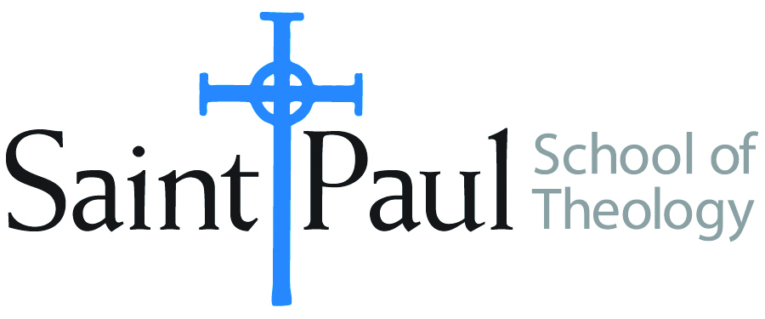
COURSE TEXTBOOK LIST INFORMATION

FACULTY INSTRUCTIONS |  |  | STUDENT INSTRUCTIONS  (Both Campuses)
For each semester taught, faculty should complete and submit a new form for every course and return to Melissa Whalen in the Academic Life office. Forms are due by the first day of registration for a given term. Desk copies for Teaching Assistants must be requested on this form. It is up to the publishers’ discretion whether or not to provide desk copies for teaching assistants. |  |  | Students may acquire textbooks by ordering online via Amazon Associate on our website and having books shipped to them. Regardless of shopping/ordering method, students may check Cokesbury online for discount on text and certain text may be sent free delivery.
COURSE INSTRUCTOR(S) | eva kathleen schulte with case studies from  CCO Executive Director, Dr. Seft Hunter
COURSE NUMBER & SECTION | PCM 348 Building Faith-Rooted Movements
COURSE NAME | Faith, Race and Power: Building Faith-Rooted Movements through Organizing
COURSE SEMESTER &YEAR | Summer Course 2017  Located: CCO-2400 Troost, Suite 4600 Kansas City, MO 64108
DATE OF SUBMISSION | 4-22-17

REQUIRED TEXTBOOKS LIST
BOOK TITLE and EDITION  (include subtitle if applicable) |  | AUTHOR(S) | No. of  PAGES to be read | PUBLISHER and DATE | 13-Digit ISBN  (without dashes) | LIST PRICE  (estimate) | DESK COPY
1 | You’re More Powerful Than You Think: A Citizen’s Guide | Eric Liu | 100 | Public Affairs. 2017 | 9781610397070 | $16.49 | yes
2
3
4
5
6
7
 | TOTAL Number of Pages to Be Read

RECOMMENDED TEXTBOOKS LIST
BOOK TITLE and EDITION  (include subtitle if applicable) |  | AUTHOR(S) | No. of  PAGES to be read | PUBLISHER and DATE | 13-Digit ISBN  (without dashes) | LIST PRICE  (estimate) | DESK COPY
1 | Faith-Rooted Organizing: Mobilizing the Church in Service to the World Alexia Salvatierra & Peter Heltzel 75 InterVarsity Press 2013 9780830836611 $12.80 yes | Alexia Salvatierra & Peter Heltzel | 75 | InterVarsity Press 2013 | 97808308  36611 | $12.80 | yes
2
3
4

Special Instructions to Cokesbury:

