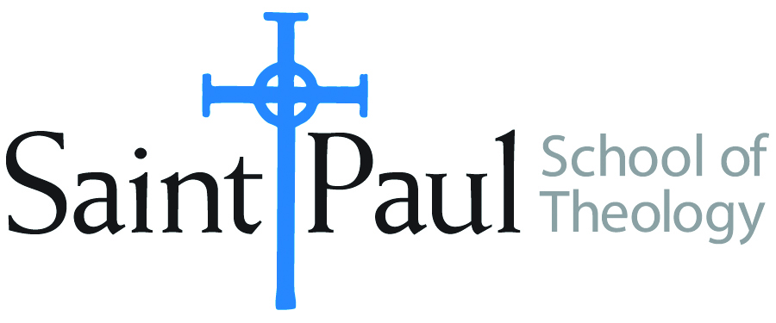 | Withdrawal Form
Use this withdrawal form for any term. To fill out this
form electronically, fill in or mark the shaded areas. You may submit a hard copy to the Registrar’s Office in 4370 W 109th Street, Suite 300, Overland Park, Kansas 66211, or you can submit it electronically, via email to tahmeka.thompson@spst.edu
or by fax to (913) 253-5075. If you have any questions, contact the Registrar’s Office at (913) 253-5026, or (913) 253-5056.
Your Information
Full Name: |  | Date:
Degree: | MDIV MACM MA(TS) DMIN NONDEG
Advisor:
Has your contact information changed? | YES NO  If yes, fill in the information below
Address:
City, State: |  | Zip:
Phone:
Student Signature: |  | Date:
Course Information

DIRECTIONS: Clearly type the course number(s), section (s) i.e. AKV, and full name of course(s) you wish to withdraw from.
COURSE | SECTION | CREDIT | COURSE NAME
Withdrawal form should only be used after the drop date for that term.

For Office Use Only (Please send to VP and Financial Aid Dir. For approval)
Please sign to approve withdrawals.
 Withdrawal Hardship  Withdrawal
________________________________ ________________________________
VPAAD Signature Date Financial Aid Director Date

