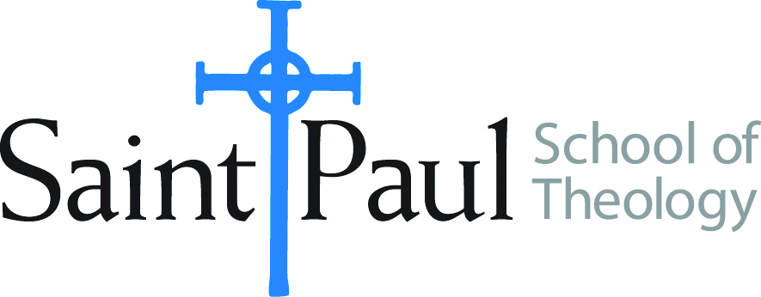
Sometimes, life happens — an emergency, an illness, anything that may require you to take an extended break from your courses. How do you handle life issues and protect your enrollment in school at the same time? Read on to learn about the leave of absence (LOA) and how it can help you.
During an LOA, you are not considered withdrawn from Saint Paul School of Theology, and federal student aid return calculations are not required.

Things to consider when taking a LOA
- Any break in attendance can cause a corresponding delay in your graduation date.
- The Associate Dean of Students for Greater Kansas City or the Associate Dean for the Oklahoma City campus may have other options and resources that can help you. Please schedule a meeting with these staff members before you request a leave of absence.
To request a LOA, please submit a Leave of Absence Form —include the reason for the request. The Leave of Absence form is available on the Saint Paul website.

Masters or Doctor of Ministry degree students may be approved for Leave of Absence for up to one year. The degree completion time requirement will not be extended but students on Leave of Absence remain in good status with Saint Paul.
Students who are not on Leave of Absence and who do not enroll for Fall or Spring semester or students who fail to return after the approved time for Leave of Absence may lose their financial aid or be withdrawn from school. The enrollment status of a student on a Master/DMIN Student Leave of Absence will be reported to lenders and loan servicing entities as ‘not attending’. Students with educational loans are advised to contact lenders for information about student rights and responsibilities regarding repayment.

Leave of absence form

Please type or print clearly in blue or black ink.

STUDENT INFORMATION
Campus: _______________________ DEGREE PROGRAM: _____________________________
FIRST NAME: ______________________________ LAST NAME: __________________________
ADDRESS __________________________ CITY _______________ STATE _____ ZIP __________
SPST EMAIL: ____________________@SPST.EDU PHONE: ______________________________
LEAVE INFORMATION
I request a leave of absence from Saint Paul School of Theology:
Effective beginning: I intend to return:
☐ Fall  ☐ Spring Year: ___________  ☐ Summer  ☐ Winter | ☐ Fall  ☐ Spring Year: ___________  ☐ Summer  ☐ Winter

Last date of attendance (the last day that you attended class) Year: __________
My reason for the requested leave of absence is:
☐ | Personal
☐ | Financial
☐ | Medical (Do Not attach documentation. We will request it if needed.)
☐ | Military deployment
☐ | Other (Please explain)

STUDENT SIGNATURE – By signing below, I certify all information included on this form to be accurate. I understand that I will need to meet with a financial aid counselor to discuss any implications this leave of absence may have on my financial aid status.

___________________________________________________ _____________
Student Signature Date

Office Use Only

___________________________________________________ ______________
Vice President of Academic Affairs and Dean Date

___________________________________________________ _______________
Director of Financial Aid Date

