Course Auditor Application
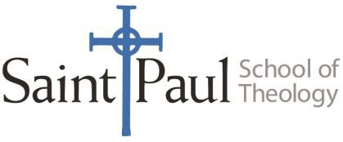

Registrar’s Office
(913)253-5026
Registrar- tahmeka.thompson@spst.edu
Registrar’s Clerk- ethel.tomlinson@spst.edu

Requirements
Applicants must complete and sign this Auditor Application form and submit to the Registrar’s office. All courses must be approved by the instructor of the course. The Registrar will facilitate this process. Auditor fees are listed below.

Audit fee for enrolled degree seeking students | $75.00 per course
Community Organizer’s Fee/ Alumni Fee | $200 per course
Non-Active/ Non- Alumni Fee | $175 per credit hour

Personal Information

Surname First Name Middle Name Preferred Name

Enrollment Information
Please indicate which course you would like to audit.

Course Code: |  |  | Course Title:
Year: |  |  | Professor:
Term: |  | Fall □ Winter □  Spring □ Summer □ | Campus: | Kansas City □Oklahoma City University □

Certification

Auditor Signature Date

_______________________________________________________________
Faculty Signature Date

